
YEAR 5 LONG TERM OVERVIEW PLANNING 2026 with:
Key Driver Texts and Parallel texts for English identified and Key Wider Curriculum Subject Drivers
 | Autumn 1 | Autumn 2 | Spring 1 | Spring 2 | Summer 1 | Summer 2
 | Quest Question  What have beetles ever done for us?  Key Drivers  Science- Living things and their habitats  FELLOWSHIP BEAUTY-WINDOW  Text Driver A:  Beetle Boy  MG Leonard  To inform  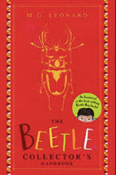  Parallel texts:  Beetle Queen  The Last Wild  Text Driver B:  Beetle Boy: The Beetle Collector's Handbook  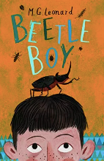  Parallel texts:  Bug Wars | Quest Question  Can year 5 save the planet?  Key Drivers  Geography  FELLOWSHIP – BEAUTY-WINDOW  Text Driver A:  The Majestic Plastic Bag/ Guardians of the Planet  To inform, to persuade  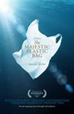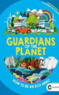  Parallel texts:  The story of a plastic spoon  Text Driver B:  One Plastic Bag  Miranda Paul  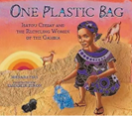  Parallel texts:  Other books by Jenny Broom- Animalium | Quest Question  Was the Victorian era a dark age or a golden age?  Key Drivers  History  COURAGE/LOVE – SELF-MIRROR  Text Driver A & B:  Cogheart  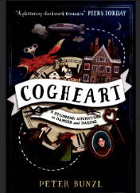  Peter Bunzl  to entertain and to persuade  Parallel texts:  Wallace and Gromit: The Wrong Trousers, The Highway Man by Alfred Noyes, The Lady of Shallot by Alfred Tennyson | Quest Question  Is the Earth the centre of the Universe?  Key Drivers  Science- Earth and Space  LOVE/FELLOWSHIP BEYOND-CANDLE  Text Driver A:  Curiosity The story of a Mars rover – Marcus Motum  Hidden Figures –  To inform, to explain  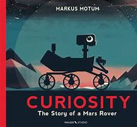  Text Driver B:  Destination Space  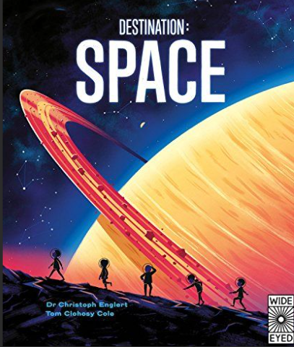  Parallel texts:  The true story of four black women and the space race.  Destination Space  Dr Christopher Englert/Tom Clohosy Cole  George’s Secret Key to the Universe, Destination Space, The Story of Astronomy and Space | Quest Question  Does the punishment fit?  Key Drivers  History: Changes in an aspect of social history,  COURAGE OTHERS-DOOR  Text Driver A:  A Midsummer's Night Dream  William Shakespeare  To persuade, to discuss, to entertain to inform  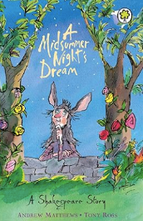  Parallel texts:  Other Shakespeare stories, other versions of A Midsummer’s Night’s Dream  Text Driver B:  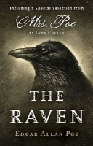  Parallel texts:  The Bells’ by Edgar Allan Poe.  To Entertain | Quest Question  Could we survive without the rainforest?  Key Drivers  Geography  COURAGE/LOVE OTHERS-DOOR AND SELF-MIRROR  Text Driver A:  The Explorer  Katherine Rundell  To entertain  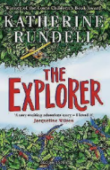  Parallel texts:  Jeremy Button, A River, Journey, Swallows and Amazons, The Floodlands, River Story
RE | UC: Freedom and Justice (UC People of God Unit 2B.3)  How can following God bring freedom and justice?  PC – Easter Prayers, New Delhi, No 9)  FELLOWSHIP | UC: Interpretation Luke, Matthew and John’s Birth Narratives (RE004 - teaching Christmas at KS2)  Why do the birth narratives differ?  LOVE | LD: Belonging Welcoming a baby into a Muslim family and the Shahada (Islam at KS2 - RE 040)  FELLOWSHIP | LD: Law: Jesus the law breaker Did Jesus do anything wrong?  COURAGE  Sacrifice and Suffering (UC Salvation Unit 2B.6 – Year 5) What did Jesus do to save human beings?  PC - The Crucifixion of the Lord in the Oberammergau passion play, No 14 | LD: Community Umma  (Islam at KS2 - RE040)  FELLOWSHIP | LD: The Good Life: Humanism  COURAGE  Holy (UC God Unit 2B.1) What does it mean if God is Holy and lovinG
SAFEGUARDING | Teach computing unit: Systems and Searching  Online Safety: Online safety  PSHE: Family and relationships | Online safety: Online Communication  DT: using tools safely – making a recycled bag  Alternate Years: Residential Trip  PSHE: Health and Well Being | Online safety: Online Reputation  PSHE: Health and well-being  Safety and the changing body | Online safety: Online Bullying  DT: using tools safely  PSHE: Safety and the changing body | Online safety: Online Health  School trip safety: Arundel Castle  PSHE: Citizenship  Economic well being  Gardening: Using Tools safely | Online safety: Online Health  PSHE: RSE – changing bodies  Transition lesson: Roles and Responsibilities  DT/Food hygiene: healthy eating and varied food groups  Poolside and Water Safety: Swimming Lessons
SCIENCE | Living things and their habitats - describe the differences in the life cycles of a mammal, an amphibian, an insect and a bird | Mixtures and changes of materials- | Forces  explain that unsupported objects fall towards the Earth because of the force of gravity acting between the Earth and the falling object | Space  describe the movement of the Earth and other planets relative to the sun in the solar system | Materials-  Properties and changes-  compare and group together everyday materials on the basis of their properties, including their hardness, solubility, transparency, conductivity (electrical and thermal), and response to magnets | Animals including humans- link with PSHE  describe the changes as humans develop to old age  describe the life process of reproduction in some plants and animals
SCIENCE | Year 1 ONLY: Seasonal Changes and ALL YEAR GROUPS: Working Scientifically throughout each unit
HISTORY |  |  | A study of an aspect or theme in British history that extends pupils’ chronological knowledge beyond 1066 - Changing power of the monarchy- Victorians- The Golden Age | Develop a chronologically secure knowledge and understanding of British, local and world history - Chronology of the Space race | A study of an aspect or theme in British history that extends pupils’ chronological knowledge beyond 1066 - Crime and punishment- link to Tudors
GEOGRAPHY | Locational knowledge | Human and physical  key topographical features coasts and rivers), how some of these aspects have changed over time |  |  |  | Human and physical/Geographical skills & fieldwork longitude, latitude, Tropics of Cancer and Capricorn, Artic, Antarctic Circle, GMT, time zones
ART | Observational drawings through the eyes of an entomologist |  | Creating a sculpture/picture Observational drawings of cogs, mechanisms, gears – innards of clocks. Design a mechanical animal for the story |  |  | Painting/mixed media  Rainforest – British artist John Dyer – Amazon. Read and research artist, sketching, design and plan art work, create art work.
DT |  | Final Straw  Make a reusable bag using recycled materials  | STEM |  | Space Buggies  Simple series of circuits, pullies wheels, axles and bearings. Build and reinforce structures | Food- Developing recipes over time
PSHE  plus  MyHappyMind | Introductory lesson: Family and relationships | Health and Well Being | Health and well-being  Safety and the changing body | Safety and the changing body | Citizenship  Economic well being | Economic well being  Transition lesson: Roles and Responsibilities
MUSIC | Year 5:  Animal Kingdom | Rivers (Y4)  L&R Handel's Water Music | Year 4:  Feel the sound  L&R - Elgar Enigma Variations | Year 5:  Planets | L&R Musical Midsummer's Night Dream | Composition- Body Percussion Creating Jungle Scapes?
MFL | Phonics and pronunciation Lesson 3  As-tu un animal? (Do You Have a Pet?) |  | La date (The Date) |  | Les vêtements (Clothes)
COMPUTING | Computing systems and networks – Systems and searching | Creating Media – Video Production | Programming A – Selection in physical computing | Data and information – Lat-file databases | Creating media – Introduction to vector graphics | Programming B – selection in quizzes
PE/GAMES | Gymnastics  GetSet4PE  Fitness | Dance  Eco Warriors  OAA  EFL Joy of Moving | Gymnastics  GetSet4PE  Pompey Football Club Outreach – Fun games and being healthy | Dance  Space dance  Basketball | Athletics  Cricket | Athletics  Swimming
ST ALBAN’S PROMISES, CURRICULUM EXPERIENCES | LQ Celebration with parents  RHS Wisley | Final Straw Workshop  LQ Celebration with parents  Wonder Dome | LQ Celebration with parents  Outdoor Learning | Expert Space workshop.  DT day – making space buggies  Goodwood Art Foundation | Arundel Castle | Swimming  Marwell

