
YEAR 4 LONG TERM OVERVIEW PLANNING with:

Key Driver Texts and Parallel texts for English identified and Key Wider Curriculum Subject Drivers

 | Autumn 1 | Autumn 2 | Spring 1 | Spring 2 | Summer 1 | Summer 2
 | Quest Question  How can we look after our world?  Geography: human and physical, biomes, climates and vegetation belts, seas, time zones  Science: Living things and their habitats – grouping and classifying animals in a variety of ways  Text Driver: Whale Boy by Nicola Davies (class reader)  LOVE (Core value)  COURAGE (Core value)  CONFLICT (Big idea)  ENVIRONMENT (Big idea)  BEAUTY-WINDOW  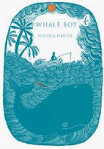  Parallel texts: Big, Blue Whale  The Blue Whale, The Storm Whale in Winter, The Storm Whale, Dear Greenpeace | Quest Question  Where does the bang come from?  Science: sound – identifying the way sounds are made through vibration and find out how the pitch and volume of sounds can be changed.  Text Driver: The Firework Maker’s Daughter by Philip Pullman ( class reader)  LOVE (Core value)  CONFLICT (Big idea)  SELF-MIRROR  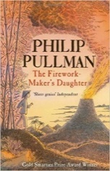  Parallel texts: non-fiction texts about Guy Fawkes, Festivals of Light | Quest Question  Where does the road lead to?  History: Romans: why did the Romans come to Britain? Cause and Consequence and the significance of this.  Geography: human settlement, land use, economic activity and trade links.  Text Driver A: The Roman Soldier’s Handbook  COURAGE (Core value)  FELLOWSHIP (Core value)  CONFLICT (Big idea)  ENVIRONMENT (Big idea)  OTHERS-DOOR  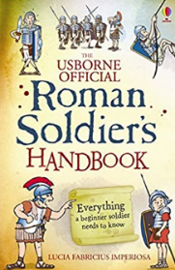  parallel texts: a range of non-fiction texts about the Romans  Text Driver B: Escape from Pompeii by Christina Ballit  COURAGE (Core value)  ENVIRONMENT (Big idea)  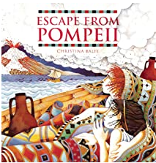  parallel texts: Secrets of Vesuvius- film I survived the…series of books, The Hurricane by David Weisner, | Quest Question  What big teeth you have!  Science: Animals including humans – teeth  Text Driver A: Hansel and Gretel (Michael Morpurgo)  COURAGE (Core Value)  DIVERSITY (Big Idea)  SELF-MIRROR  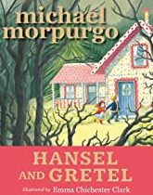  parallel texts: other versions of Hansel and Gretel, fairy tales  Text Driver B: Into the Forest by Anthony Browne  COURAGE (Core value)  ENVIRONMENT (Big idea)  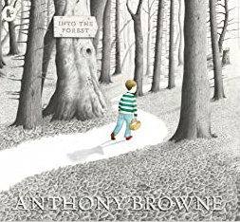  Parallel texts: Hide and Seek, Voices in the Park by Anthony Browne AUTHOR STUDY | Quest Question  Were the Vikings raiders or traders?  history: conflict (Viking and Anglo Saxon conflict) and interpretation of the past  Text driver: How to Train your Dragon – Cressida Cowell  COURAGE (Core value)  FELLOWSHIP (Core value)  CONFLICT (Big idea)  OTHERS-DOOR  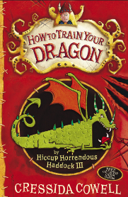  parallel texts: The Saga of Erik the Viking, Vikings in 30 seconds, There’s a Viking in my bed, Who were the Vikings?, Beowulf | Quest Question  How does it go round and round?  science: States of matter, including the water cycle  Text Driver A : The Tempest by William Shakespeare  LOVE (Core value)  COURAGE (Core value)  CONFLICT (Big idea)  ENVIRONMENT (Big idea)  BEYOND-CANDLE  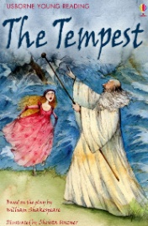  Parallel texts: FLOOD by Alvaro Villa  Non-fiction texts about the water cycle  Text Driver B: Kensuke’s Kingdom by Michael Morpurgo (class reader)  Parallel texts: FLOOD by Alvaro Villa  Non-fiction texts about the water cycle  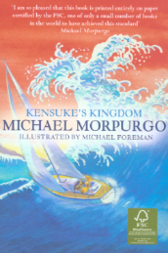
RE | People of God  What is it like to follow God?  (UC Unit 2A.2) | Incarnation  What is the trinity?  (UC Incarnation Unit 2A.3) | Myth  Hinduism  (Living Difference) | Salvation  The cross as a Christian symbol  (UC Unit 2A.1) | Kingdom of God  When Jesus left, what was the impact of Pentecost?  (UC Unit 2A.6) | Devotion  Hinduism  (Living Difference)
SAFEGUARDING | Teach computing unit: the Internet  Online safety: showing respect on-line  PSHE: Family and Relationships  Listen2Me – musical instruments | Online safety  DT: using tools safely  School trip: science museum  Listen2Me – musical instruments  PSHE: Health and Wellbeing | Online Safety: Powerful Passwords  DT: using tools safely  Listen2Me – musical instruments  PSHE: Health and Wellbeing Citizenship | Online Safety: My on-line community  Gardening: Using Tools safely  Listen2Me – musical instruments  DT: using tools safely  PSHE: Citizenship | Online Safety: My on-line community  Teach Computing: Photo Editing  Gardening: Using Tools safely  Food hygiene: healthy and varied diet  Listen2Me – musical instruments  PSHE: Economic Wellbeing Identity Safety and the changing body (inc RSE) | Gardening: Using Tools safely  Listen2Me – musical instruments  School trip safety: travelling to London and The Globe  PSHE: Safety and the changing body (inc RSE) Transition lesson: Dealing with change
SCIENCE | Living things and their habitats  Recognise that living things can be grouped in a variety of ways  Explore and use classification keys to help group, identify and name a variety of living things in their local and wider environment  Recognise that environments can change and that this can sometimes pose dangers to living things | Sound and Electricity  Identify how sounds are made, associating some of them with something vibrating  Recognise that vibrations from sounds travel through a medium to the ear  Find patterns between the pitch of a sound and features of the object that produced it  Find patterns between the volume of a sound and the strength of the vibrations that produced it  Recognise that sounds get fainter as the distance from the sound source increases  Electricity –  Identify common appliances that run on electricity  Construct a simple series electrical circuit, identifying and naming its basic parts, including cells, wires, bulbs, switches and buzzers  Identify whether or not a lamp will light in a simple series circuit, based on whether or not the lamp is part of a complete loop with a battery  Recognise that a switch opens and closes a circuit and associate this with whether or not a lamp lights in a simple series circuit  Recognise some common conductors and insulators, and associate metals with being good conductors |  | Animals Including humans  Identify the different types of teeth in humans and their simple functions  Construct and interpret a variety of food chains, identifying producers, predators and prey |  | States of Matter  Compare and group materials together, according to whether they are solids, liquids or gases  Observe that some materials change state when they are heated or cooled, and measure or research the temperature at which this happens in degrees celsius (°c)  Identify the part played by evaporation and condensation in the water cycle and associate the rate of evaporation with temperature
SCIENCE | Working Scientifically throughout each unit
HISTORY |  |  | Romans  Settlement - Roman withdrawal from Britain in c. AD 410 and the fall of the western Roman Empire  The Roman Empire and its impact on Britain. |  | Viking and Anglo-Saxons  Anglo-Saxon invasions, settlements and kingdoms: place names and village life Anglo-Saxon art and culture  The Viking and Anglo-Saxon struggle for the Kingdom of England to the time of Edward the Confessor
GEOGRAPHY | Human and physical geography:  Describe and understand key aspects of:  Physical geography, including: climate zones, biomes and vegetation belts.  Locational Knowledge:  Identify the position and significance of:  the Prime/Greenwich Meridian and time zones (including day and night) |  | Human and physical geography:  Describe and understand key aspects of human geography including types of settlement and land use, economic activity including trade links.  Location and characteristics of the world and it’s physical features (volcanoes)  Describe and understand key aspects of physical Geography including volcanoes and earthquakes. |  | Human and physical geography:  Describe and understand key aspects of human geography including types of settlement and land use, economic activity including trade links. | Human and physical  Geography:  Describe and understand key aspects of the Water Cycle.  Geographical skills and  fieldwork  Use fieldwork to observe,  measure, record and  present the human and  physical features in the  local area using a range of  methods, including sketch  maps, plans and graphs
ART | Collage  Improve their mastery of art and design techniques, including drawing, painting and sculpture with a range of materials.  Develop their techniques, including their control and their use of materials, with creativity, experimentation and an increasing awareness of different kinds of art, craft and design.  Create sketch books to record their observations and use them to review and revisit ideas.  Improve their mastery of art and design techniques, including drawing, painting and sculpture with a range of materials  Research and explore artwork by great artists, architects and designers in history (Van Gogh) |  | Clay relief  Roman deity, hero or emperor  Develop their techniques, including their control and their use of materials, with creativity, experimentation and an increasing awareness of different kinds of art, craft and design.  Create sketch books to record their observations and use them to review and revisit ideas.  Improve their mastery of art and design techniques, including drawing, painting and sculpture with a range of materials | Scientific drawings  The digestive system.  Pupils should be taught to develop their techniques, including their control and experimentation and an increasing awareness of different kinds of art
DT | Cookies! End of Quest celebration  Research source country of each ingredient, make and decorate cookies | Christmas Lanterns  Design:  research and develop design criteria to inform the design  generate, develop, model and communicate their ideas through discussion, annotated sketches  Make:  select from and use a wider range of tools and equipment to perform practical tasks.  select from and use a wider range of materials and components  Evaluate:  investigate and analyse a range of existing products evaluate their ideas and products against their own design criteria and consider the views of others to improve their work  Technical knowledge  understand and use electrical systems in their products [for example, series circuits incorporating switches, bulbs, buzzers and motors] |  |  | Viking longships  Design:  research and develop design criteria to inform the design  generate, develop, model and communicate their ideas through discussion, annotated sketches  Make:  select from and use a wider range of tools and equipment to perform practical tasks.  select from and use a wider range of materials and components  Evaluate:  investigate and analyse a range of existing products evaluate their ideas and products against their own design criteria and consider the views of others to improve their work  apply their understanding of how to strengthen, stiffen and reinforce more complex structures | Design:  research and develop design criteria to inform the design  generate, develop, model and communicate their ideas through discussion, annotated sketches  Make:  select from and use a wider range of tools and equipment to perform practical tasks.  select from and use a wider range of materials and components  Evaluate:  investigate and analyse a range of existing products evaluate their ideas and products against their own design criteria and consider the views of others to improve their work  apply their understanding of how to strengthen, stiffen and reinforce more complex structures  Technical knowledge  understand and use mechanical systems in their products [for example, gears, pulleys, cams, levers and linkages]
PSHE  (Kapow) | Introductory lesson  Family and Relationships | Health and Wellbeing | Health and Wellbeing  Citizenship | Citizenship  Economic Wellbeing | Economic Wellbeing  Identity  Safety and the changing body (inc RSE) | Safety and the changing body (inc RSE)  Transition lesson: Dealing with change
MFL: FRENCH | La Phonétique - phonics and pronounciation (4 lessons)  Je me présente - presenting myself (6 lessons) |  | Ma famille (My Family) | Chez moi (My Home) |  | Au salon de thé (At the Tea Room)
MUSIC | Hampshire School Music Service – Samba drums  Music appreciation and creating soundscapes inspired by the ocean and whale song | Hampshire School Music Service – Samba drums  Music appreciation – The Firebird – Stravinsky  Handels music for Fireworks | Hampshire School Music Service - Ukulele  Marching – drumming in the woods (ten;ten flourishing project) | Hampshire School Music Service - Ukulele | Hampshire School Music Service | Hampshire School Music Service
COMPUTING  Teach Computing | Year 4  The Internet | Year 4  Audio production | Year 4  Programming A: Repetition in shapes | Year 4  Data logging | Year 4  Photo editing | Year 4  Programming B: Repetition in games
PE/GAMES | Dance: Create characters and narratives through movement and gesture  Games – invasion games (Rugby) | Dance: Create characters and narratives through movement and gesture  Games – invasion games  (Hockey) | Gymnastics  Games: Invasion Games  (Netball) | Gymnastics  Games Invasion games  (Netball) | Gymnastics  Games Invasion games  (Tennis) | Games: Badminton  Games: Rounders
ST ALBAN’S PROMISES, CURRICULUM EXPERIENCES |  | Visit to the science museum | Roman play |  | Portals to the past – Viking Man | The Globe

