
YEAR 1 LONG TERM OVERVIEW PLANNING with:
Key Driver Texts and Parallel texts for English identified and Key Wider Curriculum Subject Drivers
 | Autumn 1 | Autumn 2 | Spring 1 | Spring 2 | Summer 1 | Summer 2
 | Quest Question  What makes me me?  LOVE  SELF-MIRROR  Key Drivers  PSHE – likes/dislikes, what makes me unique?  Science – animals including humans  Text Driver A:  Can I build another me? – Shinsuke Yoshitake  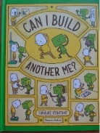  Parallel texts:  Rainbow fish  Mr Tiger Goes Wild | Quest Question  Can we go to the moon?  COURAGE  BEYOND-CANDLE  Key Drivers  History – events outside of living memory – Niel Armstrong focus.  Text Driver A:  Bob the man on the moon.  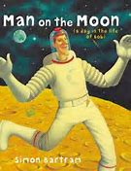  Parallel texts:  Q Pootle 5, UFO Diary | Quest Question  What was it like to live in a castle?  FELLOWSHIP  BEAUTY – WINDOW  Key Drivers  History – compare aspects of life in different periods  Text Driver A:  George and the Dragon  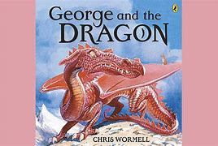  Parallel texts:  Avoid being in a medieval castle – Jacqueline Morley | Quest Question  Will my bulb still grow if I plant it upside down?  LOVE  BEAUTY-WIINDOW  Key Drivers  Science – enquiry working scientifically.  Text Driver A:  Jack and the Beanstalk  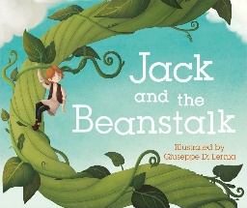  Parallel texts:  Tidy by Emily Grawett | Quest Question  What’s so great about Great Britain?  FELLOWSHIP  OTHERS-DOOR  Key Drivers  Geography – identify human and physical features of the UK.  Text Driver A:  Biscuit Bear  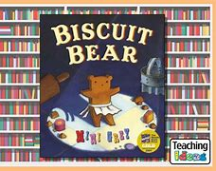  Parallel texts:  Other books by Mini Grey  Martha Maps it out | Quest Question  What was life like at the seaside 100 years ago?  LOVE  OTHERS-DOOR  Key Drivers  History – changes within living memory.  Text Driver A:  Lighthouse Keeper’s lunch  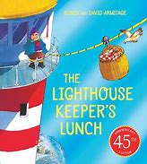  Parallel texts:  Other books in the Lighthouse Keeper’s series
 | Text Driver B: The Storm Whale  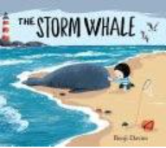  Outcome:  Purpose: Inform  Audience: Beach users  Form: Poster  Viewpoint: Benji  LOVE (Core value)  COURAGE (Core value)  FELLOWSHIP (Core value)  ENVIRONMENT (Big idea)  BEAUTY-WINDOW  APPRENTICE WRITES  Diary entry of the Whale  Parallel texts: The Storm Whale in Winter | Text Driver B:  The Snowman  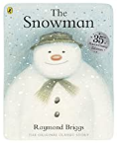  Outcome:  Purpose: Entertain  Audience: Yr R  Form: narrative  Viewpoint: snowman  LOVE (Core value)  COURAGE (Core value) FELLOWSHIP (Core value)  ENVIRONMENT (Big idea)  OTHERS-DOOR  Parallel Texts: Father Christmas  APPRENTICE WRITES: Write postcards when visiting Father Christmas | Text Driver B: Peep Inside the Castle  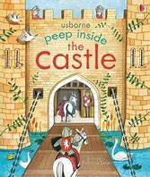  Outcome:  Purpose: Inform  Audience: Peers  Form: Peep inside information page  Viewpoint: Expert  COURAGE (Core value)  FELLOWSHIP (Core value)  BEAUTY-WINDOW  APPRENTICE WRITES  Information page about favourite building  Parallel texts: Usborne non-fiction series | Text Driver B: We plant a seed  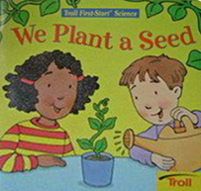  Outcome:  Purpose: instruct  Audience: Gardeners  Form: Instructions  Viewpoint: Expert gardener  LOVE (Core value)  COURAGE (Core value)  FELLOWSHIP (Core value)  ENVIRONMENT (Big idea)  BEAUTY-WINDOW  Parallel Texts: A seed in Need, The Tiny Seed, One little seed, Plant the Tiny Seed  APPRENTICE WRITES  Fact sheet about what a seed needs to grow. | Text Driver B:  Dear Mother Goose  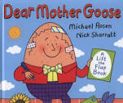  Outcome:  Purpose: Narrative  Audience: Mother Goose  Form: Character profile  Viewpoint: Author  LOVE (Core value)  COURAGE (Core value)  SELF-MIRROR  APPRENTICE WRITES:  Letter in role  Parallel texts:  Other traditional tales | Text Driver B: Something Fishy – film unit  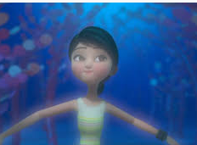  Outcome:  Purpose: Entertain Audience: Parents LQ celebration  Form: Narrative  Viewpoint:  COURAGE (Core Value)  ENVIRONMENT (Big idea)  BEAUTY-WINDOW  Parallel texts: Seaside poems by Jill Bennett, Commotion in the Ocean, Billy’s Bucket by Kes Gray  Apprentice Writes:  Re-write the ending of Billy’s Bucket – what do they see when they look into it? (Billy’s Bucket)
RE | Christianity  Concept – Creation  Bible Story – Genesis 1 | Christianity  Concept – Journey's End  Bible Story – Nativity/Babushka | Judiasm  Concept – Belonging  Bible Story - Jesus welcoming the children | Christianity  Concept – Sadness to happiness  Bible Story – The Easter story | Christianity  Concept – Friendliness  Bible Story - Parable of the tax collector | Hinduism and Christianity  Concept – Ideas about God  Bible Story - Moses and the burning bush/ Daniel in the lion’s den
SAFEGUARDING | Using Year 1 provision safely  PSHE: Family and Relationships  PE: Travelling safely using our body | PSHE: Family and Relationships  Health and Wellbeing  PE: dance and catching  Trip to the Sustainability centre – trip safety | PSHE: Health and Wellbeing Safety and the Changing Body PE: landing safely | Science/trailblazing: washing our hands after contact with soil  PSHE: Safety and the Changing Body  DT: using tools safely | Art outside: using natural materials safely  PSHE: Citizenship and Economic Wellbeing PE: sending/kicking and striking | DT: using tools safely Gardening: Using Tools safely  Food hygiene: healthy eating and varied food groups  PSHE: Transition, Economic Wellbeing  Trip to Tuppenny Barn: School trip safety  Athletics and Sports Day
SCIENCE | Animals including humans  Identify and name a variety of common animals including fish, amphibians, reptiles, birds and mammals.  Identify and name a variety of common animals that are carnivores, herbivores and omnivores.  Describe and compare the structure of a variety of common animals (fish, amphibians, reptiles, birds and mammals, including pets).  Identify, name, draw and label the basic parts of the human body and say which part of the body is associated with each sense. | Everyday materials  Distinguish between an object and the material from which it is made.  Identify and name a variety of everyday materials, including wood, plastic, glass, metal, water, and rock.  Describe the simple physical properties of a variety of everyday materials. |  | Plants  Identify and name a variety of common wild and garden plants, including deciduous and evergreen trees.  Identify and describe the basic structure of a variety of common flowering plants, including trees. | Seasonal changes  Observe changes across the four seasons.  Observe and describe weather associated with the seasons and how day length varies.
SCIENCE | Year 1 ONLY: Seasonal Changes and ALL YEAR GROUPS: Working Scientifically throughout each unit
HISTORY | What makes me, me?  Changes within living memory. Where appropriate, these should be used to reveal aspects of change in national life. | Neil Armstrong  Events beyond living memory that are significant nationally or globally.  The lives of significant individuals in the past who have contributed to national and international achievements. | What was it like to live in a castle?  Significant historical events, people and places in their own locality. |  |  | What was life like at the seaside 150 years ago? Changes within living memory. Where appropriate, these should be used to reveal aspects of change in national life.  Significant historical events, people and places in their own locality.
GEOGRAPHY |  |  |  | Geographical skills and fieldwork  Use aerial photographs and plan perspectives to recognise landmarks and basic human and physical features; devise a simple map; and use and construct basic symbols in a key. Use simple fieldwork and observational skills to study the geography of their school and its grounds and the key human and physical features of its surrounding environment. | Locational knowledge  Name, locate and identify characteristics of the four countries and capital cities of the United Kingdom and its surrounding seas.  Name and locate the world’s seven continents and five oceans  Place Knowledge Understand geographical similarities and differences through studying the human and physical geography of a small area of the United Kingdom, and of a small area in a contrasting non-European country. | Human and physical, geography  identify seasonal and daily weather patterns in the UK and the location of hot and cold areas of the world in relation to the Equator and the North and South Poles
ART |  |  | Paul Klee  Learn about the work of a range of artists, craft makers and designers, describing the differences and similarities between different practices and disciplines, and making links to their own work. | Pablo Picasso – Mother’s Day painting  To develop a wide range of art and design techniques in using colour, pattern, texture, line, shape, form and space. | Andy Goldsworthy  To use a range of materials creatively to design and make products.  To use drawing, painting and sculpture to develop and share their ideas, experiences and imagination.  Learn about the work of a range of artists, craft makers and designers, describing the differences and similarities between different practices and disciplines, and making links to their own work.
DT |  |  |  | Design and create a planter box for the seed  Design  Make  Evaluate |  | Make a healthy lunch  Design  Make  Evaluate
PSHE | Introduction lesson  Family and Relationships - Kapow | Family and Relationships  Health and Wellbeing - Kapow | Health and Wellbeing  Safety and the changing body - Kapow | Safety and the changing body  Citizenship - Kapow | Citizenship  Economic Wellbeing - Kapow | Economic Wellbeing  Transition lesson - Kapow
MUSIC | All about Me  Use their voices expressively and creatively by singing songs and speaking chants and rhymes. | Listening and responding: Gustav Holst’s Planet Suite | BBC 10 Pieces ‘No Place Like…’ | Jack and the Beanstalk  Primary Music KS1: Jack and the Beanstalk - BBC Teach
COMPUTING | Technology all around us – teach computing | Creating digital media – teach computing | Programming a robot – teach computing | Grouping data – teach computing | Digital writing – teach computing | Creating animations – teach computing – teach computing
PE/GAMES | Gym Travelling on different parts of the body.  Games Movement | Dance – Toys – GS4PPE  Games Bouncing and catching | Gym Flight, Bouncing, Landing  Games Fundamental movement | Dance Toys  Games Multiskills | Gym Rocking and Rolling  Games Sending, kicking, striking | Dance Under the Sea  Games Athletics, Sports day
ST ALBAN’S PROMISES, CURRICULUM EXPERIENCES | Continuous Provision as a transition from YR | Continuous Provision as a transition from YR  Sustainability centre trip |  | Mother’s Day Worship – Present our portraits |  | Trip to Tuppenny Barn

