
YEAR 3 LONG TERM OVERVIEW PLANNING with:
Key Driver Texts and Parallel texts for English identified and Key Wider Curriculum Subject Drivers
 | Autumn 1 | Autumn 2 | Spring 1 | Spring 2 | Summer 1 | Summer 2
 | Quest Question  How do you walk like an Egyptian?  Key Drivers  History  COURAGE BEAUTY-WINDOW  Text Driver A:  Scarab’s Secret  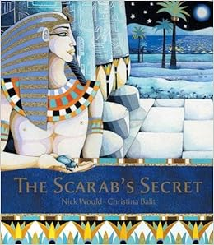  Parallel texts:  Egyptian non-fiction  Text Driver B:  Egyptian Cinderella  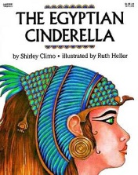  Parallel texts:  Other Cinderella stories from around the world:  - The Korean Cinderella – Shirley Climo  - Yeh-Shen: A Cinderella Story from China – retold by Ai-Ling Louie  - Mufaro’s Beautiful Daughters: An African Tale – John Steptoe | Quest Question  Should we be afraid of the dark?  Key Drivers  Science  COURAGE BEAUTY-WINDOW  Text Driver A:  The Night Box  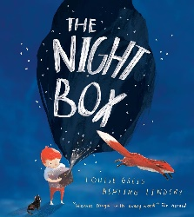  Text Driver B:  Flashlight  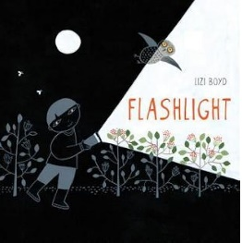  Parallel texts:  - Orion and the Dark – Emma Yarlett  - The Dark – Lemony Snicket & Jon Klassen.  - Can’t You Sleep, Little Bear? – Martin Waddell & Barbara Firth | Quest Question  Where have we come from?  Key Drivers  History  COURAGE OTHERS - DOOR  Text Driver A:  Stone Age Boy  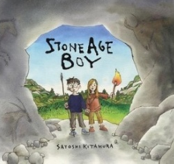  Text Driver B:  Skara Brae  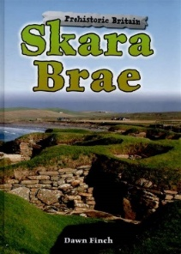  Parallel texts:  - Stig of the Dump – Clive King  - Ug: Boy Genius of the Stone Age by Raymond Briggs  - The First Drawing – Mordicai Gerstein  - Cave Baby – Julia Donaldson & Emily Gravett  - The Secrets of Stonehenge – Mick Manning, Brita Granstrom | Quest Question  How do I stand up?  Key Drivers  Science  COURAGE SELF-MIRROR  Text Driver A:  Bones  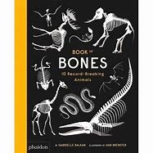  Text Driver B:  The Jabberwocky  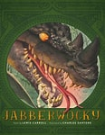  Parallel texts:  - Dr Roopa's Body Books: The Super Skeleton  - Funnybones – Janet & Allan Ahlberg  - Bone by Bone: Comparing Animal Skeletons – Sara Levine | Quest Question  Where are the 7 wonders of the world?  Key Drivers  Science  FELLOWSHIP – BEAUTY-WINDOW  Text Driver A:  Land of Neverbelieve  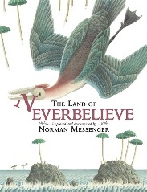  Parallel texts:  A range of non-fiction texts about the seven wonders of the world.  - The Mysteries of Harris Burdick  - by Chris Van Allsburg  - The Wonder Garden -  - Jenny Broom, Kristjana S Williams  - Journey - Aaron Becker  - Flotsam - David Wiesner | Quest Question  How has Havant changed since 1066?  Key Drivers  History  FELLOWSHIP -OTHERS-WINDOW  Text Driver A:  Wild Robot  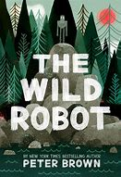  Parallel texts:  - The Iron Man – Ted Hughes  - The Iron Woman – Ted Hughes  - The Robot and the Bluebird – David Lucas  - Lady Oak: A History of Staunton Country Park – David Ludlam (Local Author)
RE | Creation/Fall - sorry | Incarnation - Angels | Good and Evil - Holi | Salvation – Hope from suffering | Gospel – The first Disciples | Protection – Raksha Bandan
SAFEGUARDING | Focus Learning Disposition:  Perseverance  - Transition: building attachments, relationships and trust  - Building friendships  - Growth Mindset and Understanding How we Learn  - School, class and computing charters  - Democracy – choosing and voting for pupil voice reps and charity focus  - How does school keep us safe?  - safety in PE/Science/Outdoors  - My Happy Mind | Focus Learning Disposition:  Collaboration  - Think Safe week: road safety, firework code and safety, Be Bright, Be Seen  - Growth Mindset and Understanding How we Learn  - Anti-bullying week  - NSPCC Speak Out, Stay Safe  - safety in PE  - safety in science  - safety in outdoor learning/trailblazers  - My Happy Mind  - Local walks, including to the Church  - Chaplaincy | Focus Learning Disposition:  Enquiry  - NSPCC PANTS  - Internet Safety Day – external provider as well  - Think Safe week: Mental Health and Well-being week (children and staff)  - Clever Never Goes  - Growth Mindset and Understanding How we Learn  - safety in PE  - safety in science  - safety in outdoor  - learning/trailblazers  - My Happy Mind  - Local walks, including to the Church  - Chaplaincy | Focus Learning Disposition: Creativity  - Growth Mindset and Understanding How we Learn  - Keeping our Friends Safe  - safety in PE  - safety in science  - safety in outdoor learning/trailblazers  - My Happy Mind  - Fairtrade Fortnight  - Local walks, including to the Church  - Chaplaincy | Focus Learning Disposition: Connection  - Clever Never Goes  - Growth Mindset and Understanding How we Learn  - safety in PE  - safety in science  - safety in outdoor learning/trailblazers  - My Happy Mind  - Christian Aid Week  - Local walks, including to the Church  - Chaplaincy | Focus Learning Disposition:  Reflection  - Think Safe week: Sea Smart and Sun Safe  - Water Safety  - Growth Mindset and Understanding How we Learn  - safety in PE  - safety in science  - safety in outdoor learning/trailblazers  - My Happy Mind  - Transition: building attachments, relationships and trust  - Building friendships  - Local walks, including to the Church  - Chaplaincy
SCIENCE | Forces and Magnets  - Compare how things move  - Understand that some forces need contact with another object  - How magnets attract and repel materials  - Group materials into magnetic and not magnetic  - Describe magnets as having two poles  - Predict which poles will attract and repel each other | Light and Shadows  - You need light in order to see  - Darkness is the absence of light  - Light is reflected from surfaces  - Sunlight is dangerous and what ways can we protect our eyes?  - How shadows are formed  - Find patterns in the way that the size of shadows change | Rocks  - Compare and group rocks on appearance and physical properties  - Describe how fossils are formed  - Recognise that soil is made from organic matter and rocks | Animals including Humans  - Animals and humans need the right types and amounts of nutrition.  - They cannot make it so they have to eat it  - Humans have skeletons and muscles for support, protection and movement | Plants  - Identify and describe functions of roots, stem, trunk, leaves and flowers on plants  - What their requirements are for growth and life  - Investigate how water is transported within a plant  - The role flowers play in the life cycle through pollination, seed formation and dispersal
SCIENCE | Year 1 ONLY: Seasonal Changes and ALL YEAR GROUPS: Working Scientifically throughout each unit
HISTORY | How do you walk like an Egyptian?  Key Drivers  History – Ancient Civilisations  NC  - the achievements of the earliest civilizations – an overview of where and when the first civilizations appeared and an in-depth study of ANCIENT EGYPT.  Courage (core value)  Fellowship (core value)  diversity (big idea)  Conflict (big idea) |  | Where have we come from?  Key Drivers  History – changes in Britain from the Stone Age to the Iron Age  NC  - Stone age to Iron age  - Changes in Britain from stone age to iron age  - How they were hunter gatherers and farmers  - Skara Brae  - Bronze age religion, technology and travel with links to Stonehenge  - Iron age hill forts, farming, art and culture  Courage (core value)  Fellowship (core value)  Environment (big idea) |  |  | Local study  How has Havant evolved since 1066?  Key Drivers  History – a study of an aspect of history or a site dating from a period beyond 1066 that is significant in Havant  NC  - A local history study - a study over time tracing how several aspects of national history are reflected in the locality.  - A study of an aspect of history or a site dating from a period beyond 1066 that is significant in the locality.  Love (core value)  Courage (core value)  Fellowship (core value)  diversity (big idea)  Environment (big idea)
GEOGRAPHY | Locational knowledge  Explore land use, settlements and rivers and deserts. Locate Egypt.  LIGHT TOUCH |  | Human and physical geography  Describe and explain how physical features (volcanoes) have had an impact upon the surrounding landscape and communities. | Human and physical geography  Biomes and how characteristics of land affects animals in North America.  LIGHT TOUCH | Human and physical geography  Describing and understanding types of settlement and land use.  Describe and understand key aspects of human and physical geography understanding similarities and differences | Geographical skills and fieldwork  Ordnance survey maps  Observing urbanisation.  Place knowledge  Compare and describe similarities and differences between a European city and Australia.
ART | Sculpture  clay canopic jar  Improve mastery of art and design techniques  NC -  become proficient in drawing, painting, sculpture and other art, craft and design techniques  know about great artists, craft makers and designers, and understand the historical and cultural development of their art forms.  Courage (core value)  Fellowship (core value)  diversity (big idea)  Conflict (big idea) |  |  | Scientific Drawing  Damin Victorian Animalism  Create sketchbooks and record observations  Great artists  NC -  become proficient in drawing, painting, sculpture and other art, craft and design techniques  evaluate and analyse creative works using the language of art, craft and design  know about great artists, craft makers and designers, and understand the historical and cultural development of their art forms.  Fellowship (core value)  diversity (big idea) | Georgia O’Keefe  Improve mastery of art and design techniques - painting  Great artists  NC -  know about great artists, craft makers and designers, and understand the historical and cultural development of their art forms.  produce creative work, exploring their ideas and recording their experiences  become proficient in drawing, painting, sculpture and other art, craft and design techniques  evaluate and analyse creative works using the language of art, craft and design  Love (core value)  Courage (core value)  Fellowship (core value)  Diversity (big idea)  Conflict (big idea
DT |  | Shadow Puppets  NC  develop the creative, technical and practical expertise needed to perform everyday tasks confidently and to participate successfully in an increasingly technological world  build and apply a repertoire of knowledge, understanding and skills in order to design and make high-quality prototypes and products for a wide range of users  critique, evaluate and test their ideas and products and the work of others  Courage (core value)  Fellowship (core value) |  | Make a moving hand  NC  build and apply a repertoire of knowledge, understanding and skills in order to design and make high-quality prototypes and products for a wide range of users  critique, evaluate and test their ideas and products and the work of others  Love (core value)  Courage (core value) Fellowship (core value)  Citizenship (big idea) |  | Can a fruit and vegetable smoothie still be tasty?  NC  critique, evaluate and test their ideas and products and the work of others -understand and apply the principles of nutrition and learn how to cook.  Love (core value)  Courage (core value)  Fellowship (core value)  Environment (big idea)
PSHE | Family and relationships | Health and wellbeing | Safety and the changing body | Citizenship | Economic Wellbeing | Transition
MUSIC | Call and response  - Call and Response  - Listening and Appreciation  - Different forms of written notation  - Percussion and recorders | Silent Night  - Reading notation  - Listening and appreciation  - Performing  - Recorder  - Singing | Body Percussion  - Listening and appreciation  - Composing  - Notation in different forms | Minimalism  - Listening and appreciation  - Notation  - Composing  - Recorder  - Percussion | Chinese pentatonic  - Kapow | UK Folk songs  - Performing  - Listening and Appreciation  - Notation  - Singing  - Recorder
MFL FRENCH | Phonics and pronunciation Lesson 1  J'apprends le français (I Am Learning French) |  | Les animaux (Animals) | Les fruits (Fruits) | Je peux... (I Am Able...)
COMPUTING | Computing systems and networks – Connecting computers | Creating media - Stop-frame animation | Programming A - Sequencing sounds | Data and information – Branching databases | Creating media – Desktop publishing | Programming B - Events and actions in programs
PE/GAMES | Dance  Fundamentals  GS4PE | Gym  Shape and shadows  Hockey  GS4PE | Dance  Netball  GS4PE | Gym  GS4PE  Basketball  GS4PE | Athletics  GS4PE  Ball Skills  GS4PE | Athletics  GS4PE  OAA  GS4PE
ST ALBAN’S PROMISES, CURRICULUM EXPERIENCES | Outdoor learning  Egyptian Workshop – In School | Recorder concert | Butser trip | Outdoor learning | Outdoor learning | Local walk

