
Love, Courage and Fellowship

Welcome to Oak Class (Year R)
2026 to 2027

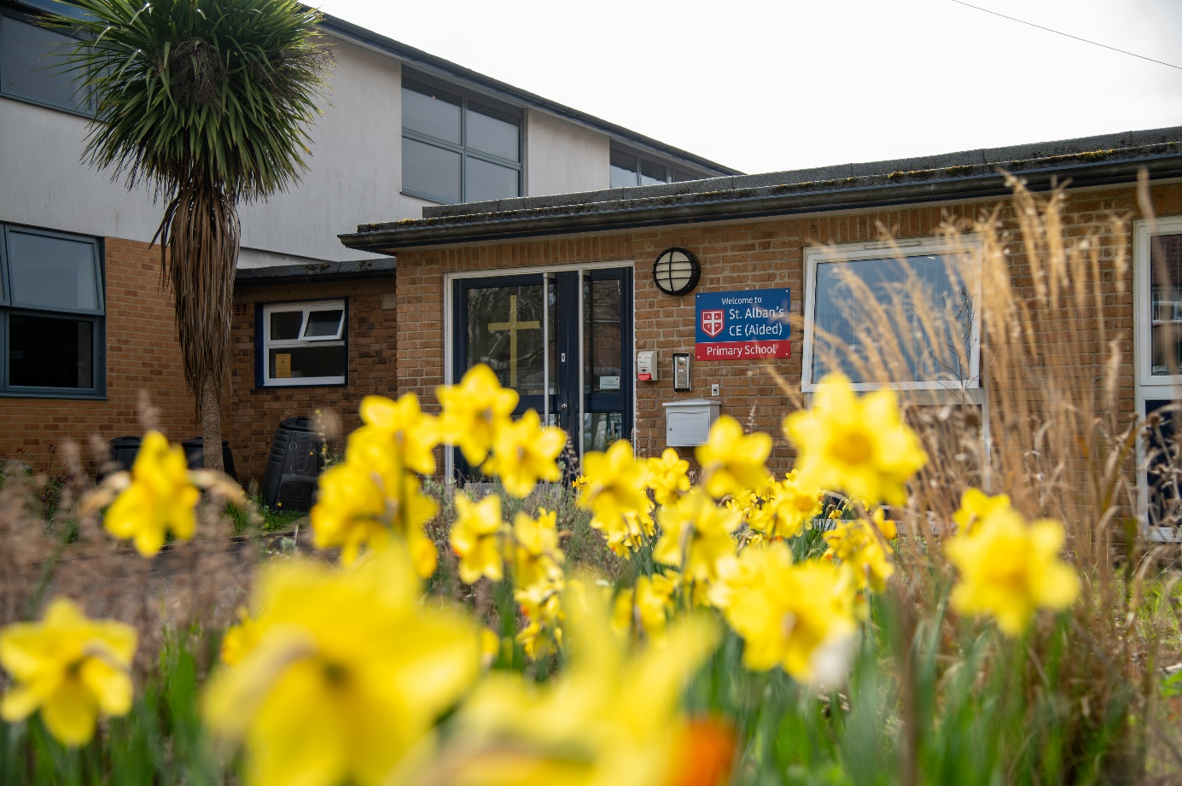

Take a look through our reception class social story with your child to learn more about what we do in Oak Class!

Welcome to St Alban’s CE Primary School!
Hello! We are so excited to meet you soon at St Albans CE Primary School. Everyone here is getting ready to welcome you with big smiles and open arms. You're going to have so much fun!
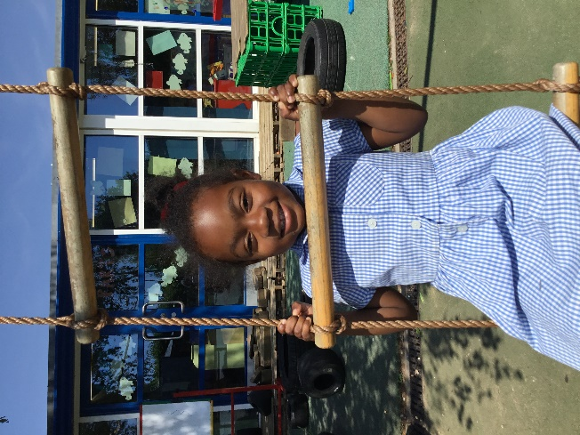

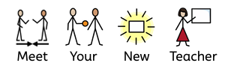

Your teacher is Mrs Evetts. She is friendly, caring, and loves helping children learn new things and enjoy their day. She is looking forward to meeting you and finding out what makes you smile.
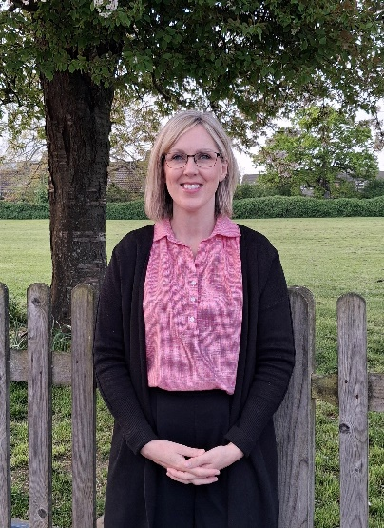

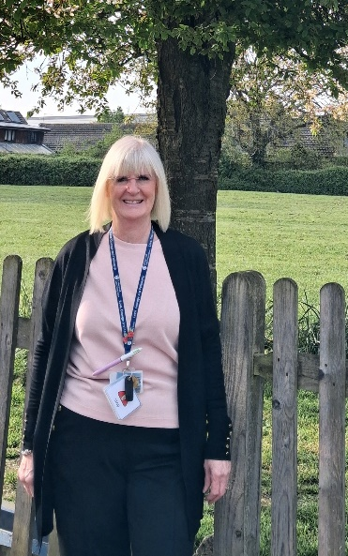
You will also learn and play with…


Mrs Howard and Mrs Griffiths

Our Headteacher is Mrs Godlsworthy. She likes to come and play in Oak class too.





At school, you’ll meet lots of other children who will want to play and be friends with you. You’ll laugh, play, and learn together every day!
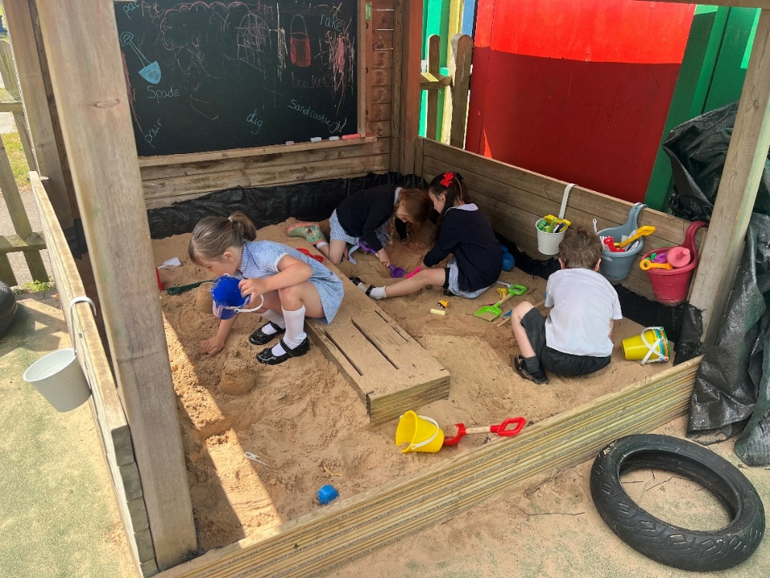

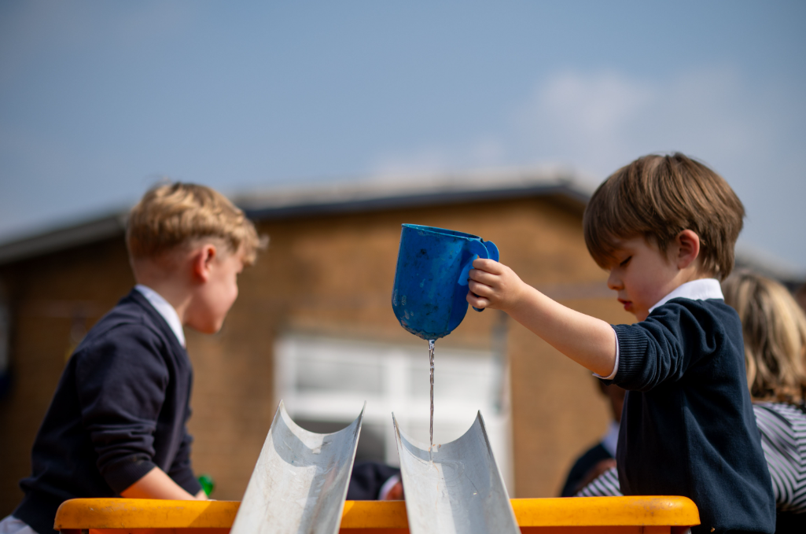
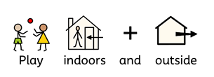

There are fun toys and games to enjoy inside the classroom, as well as exciting places to play outside too! Every day you can build, dress up, climb and explore our class garden area, discovering new ways to learn and have fun.
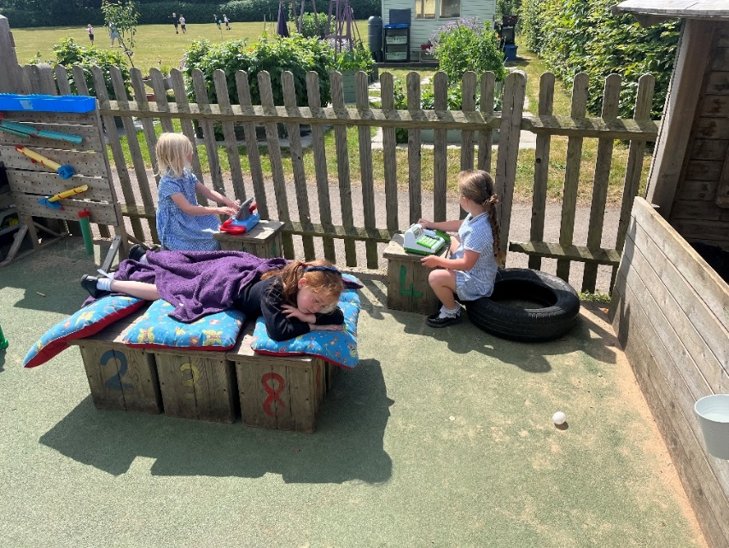

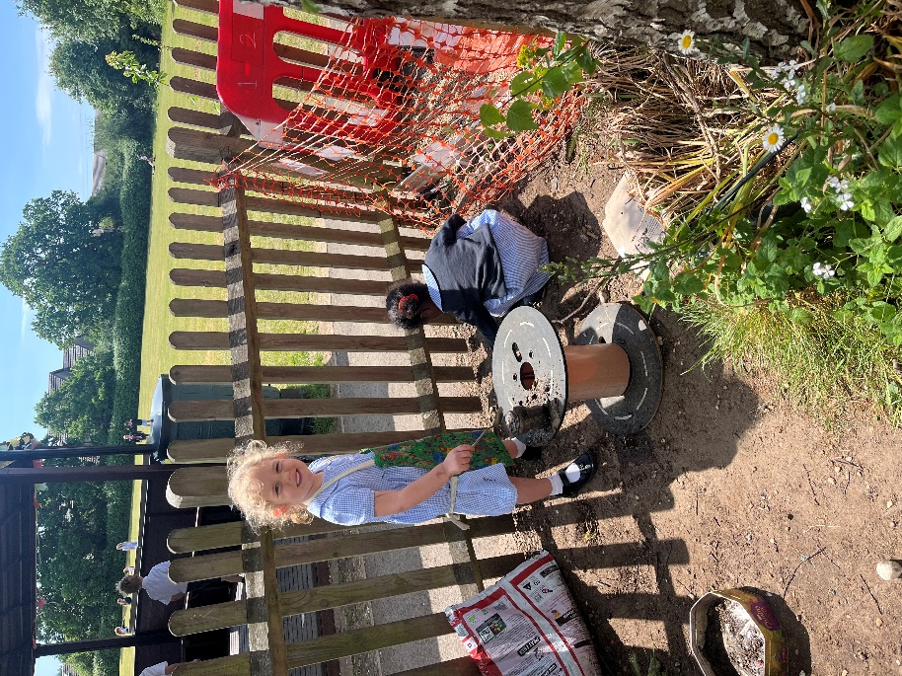

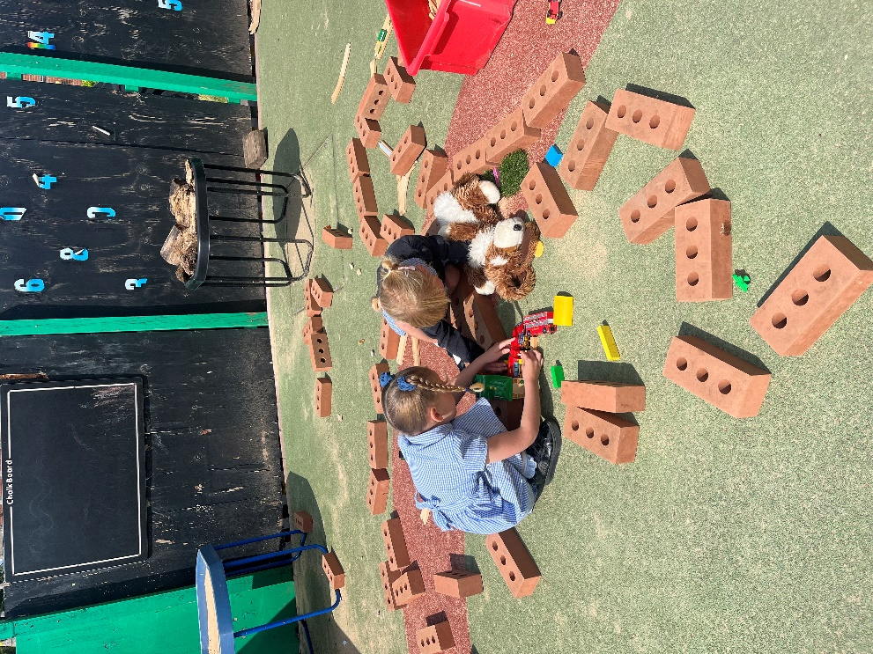

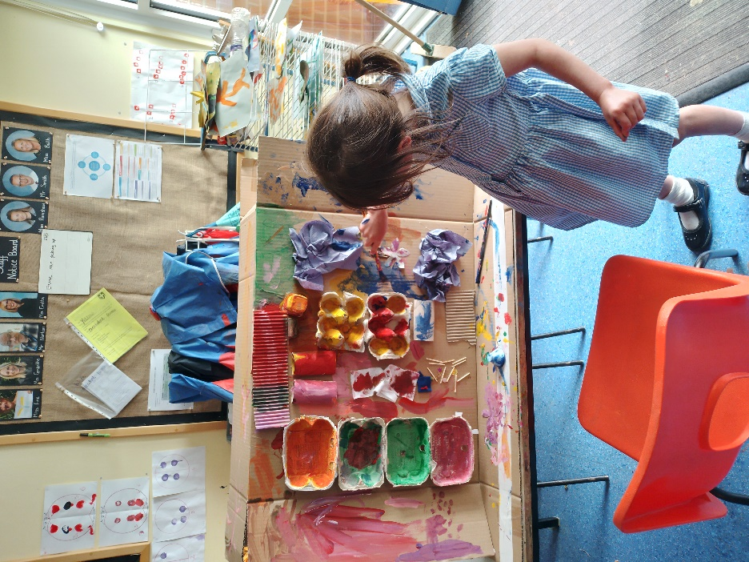

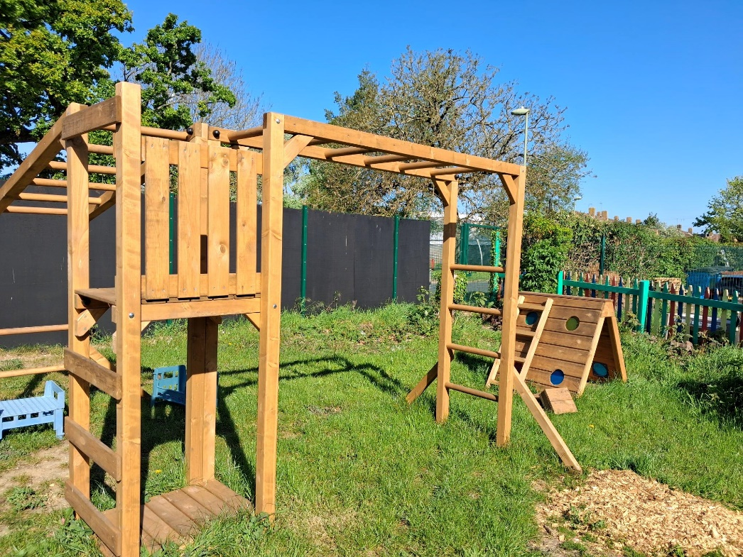



Every Wednesday, we head out on our Welly Wednesday adventure to go trail blazing on the school field. Wearing our wellies, we explore the outdoors, look for birds and bugs and enjoy splashing in puddles as we discover nature together!
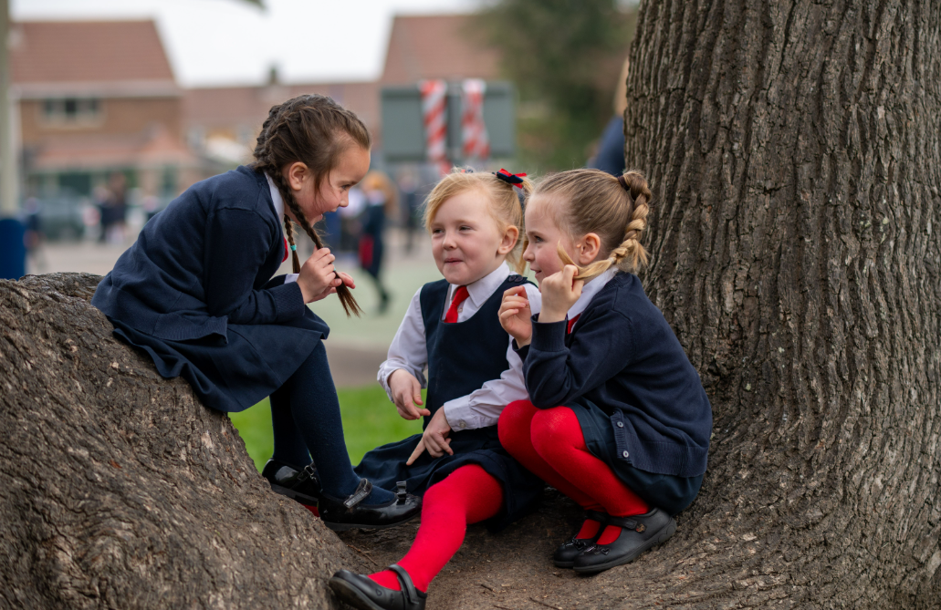



When you begin staying at lunchtimes, kind and helpful adults will help you find your seat and eat your lunch. They’ll look after you and keep you happy.

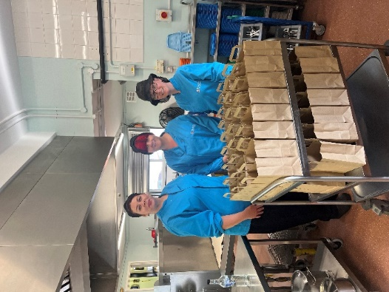



During the day, you can enjoy a snack and some milk. It’s a nice time to sit down, have a chat, and get ready for more fun!

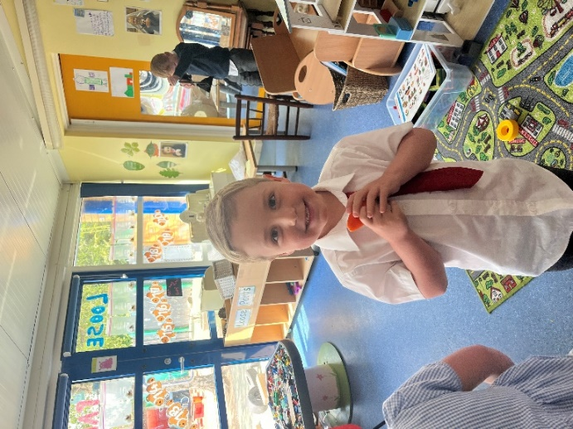

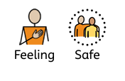

There are lots of soft teddies and toys to cuddle and play with, helping you feel cosy and happy. Your teachers are always there to help and support you, so you’ll feel safe and cared for in your new school.

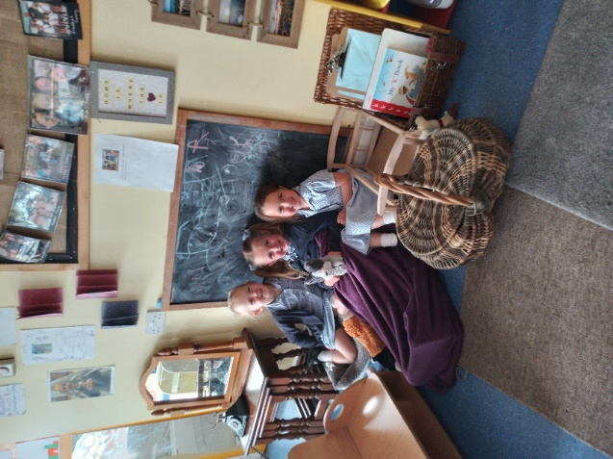

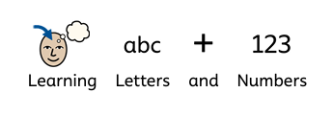

You’ll learn lots of exciting new things, like letter sounds and numbers. Every day is a fun learning adventure where your brain grows bigger and stronger!
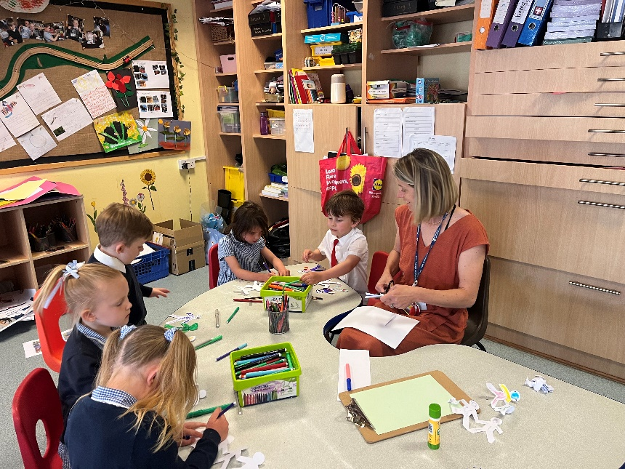

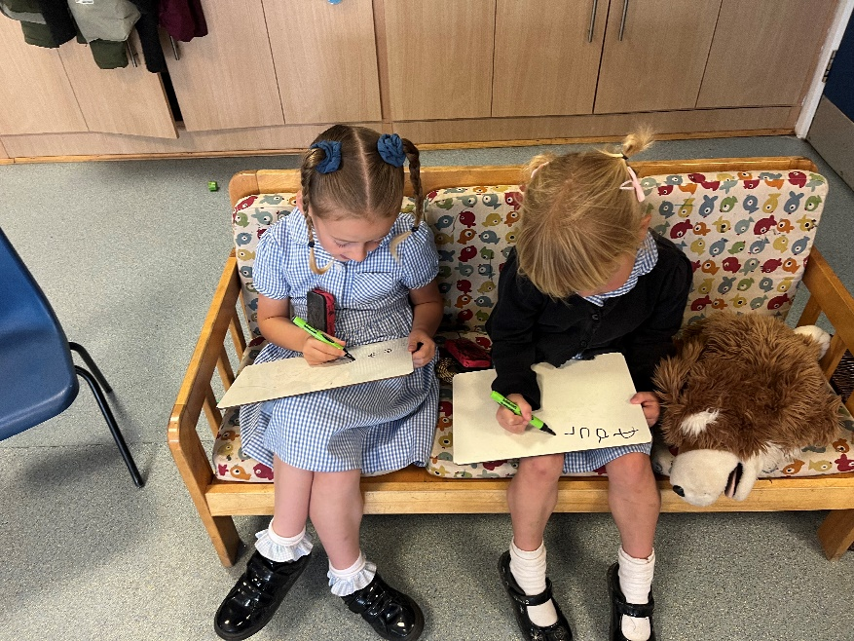



You’ll wear a smart new uniform that shows you belong to our school family. We’ll all look proud, confident, and ready to learn together!

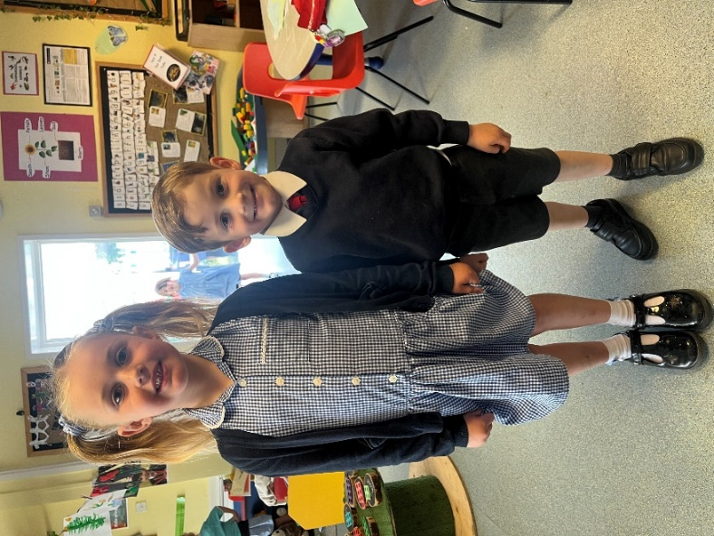



You’ll have your very own school bag and water bottle to bring each day, ready for school adventures. Inside you can carry your special things, like your exciting reading book, helping you feel confident and ready to learn

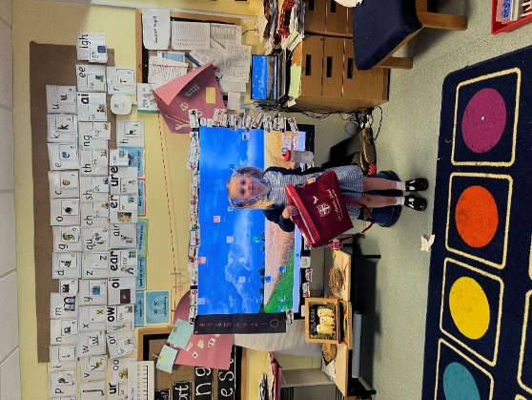



There are so many lovely storybooks to enjoy. We’ll read together, explore exciting adventures, and discover new characters and ideas through stories every day. Every Friday, a mystery reader will visit to share a surprise story with us!
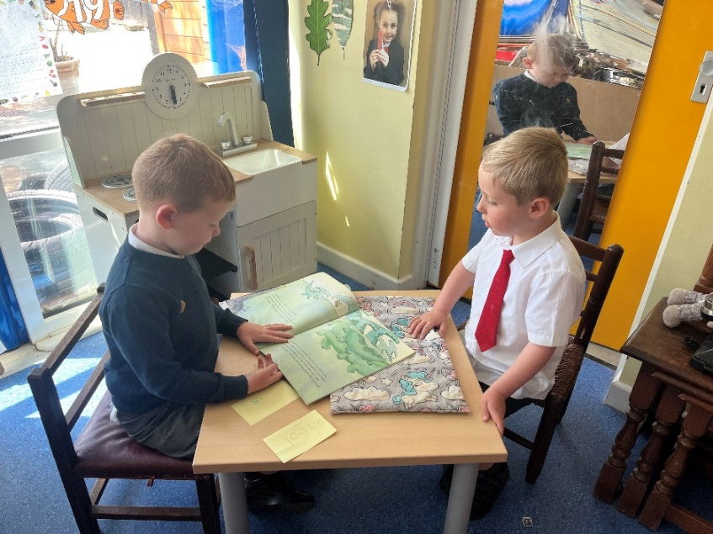

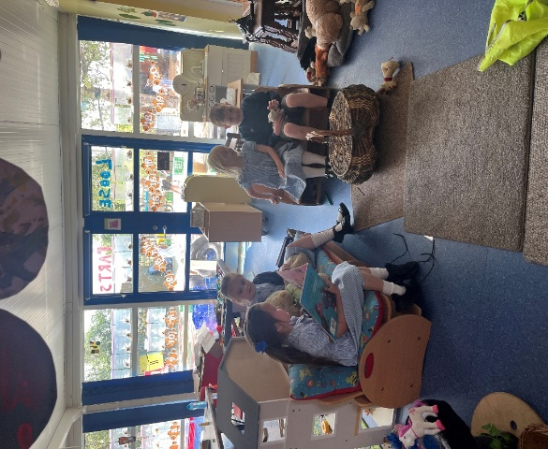

We can’t wait to welcome you and begin this wonderful journey together. You are going to do amazing things, and we’ll be right beside you every step of the way, helping you shine!

