
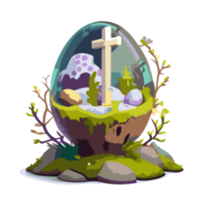
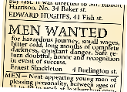
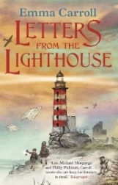
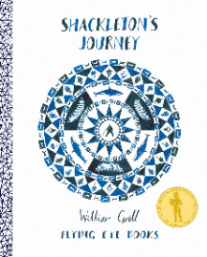
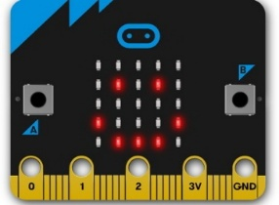
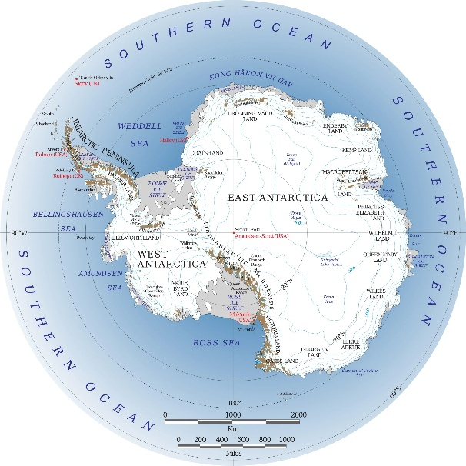

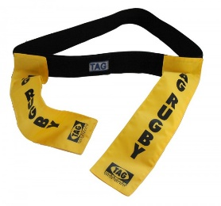


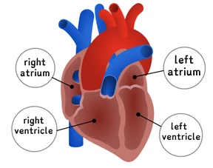
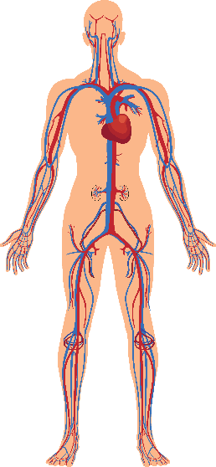
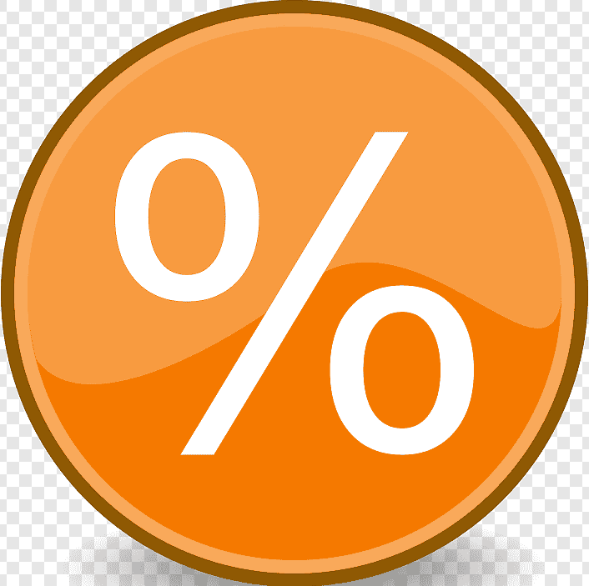
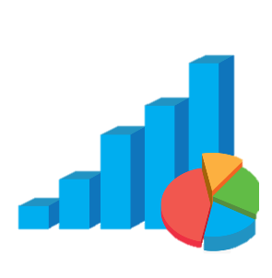
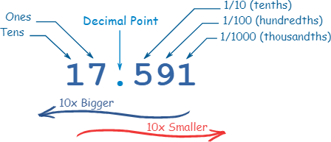
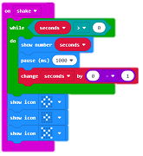

Safeguarding
This half term, we will be putting the things we have learnt from Lee Haywood’s visit into practice. We will think about the impact of AI on our lives and discuss our online safety further.
In addition, we will consider online issues that give us negative feelings and know how to get help, explore the impact and consequences of sharing online and learn how to create a positive online reputation.
As geographers, we will develop our understanding of global biomes by exploring their locations, climates, vegetation and wildlife, and examining how humans interact with and impact these environments. We will strengthen our geographical skills through map work, data interpretation and comparison, and think critically about sustainability, climate change and global responsibility.

DAILY
Reading: Rocket Reads recorded in your Reading Diary; make sure you get it signed by an adult.
Maths: TTRS – make sure your heatmap is green. If you know your facts to 12 x 12, start learning your 13 – 19 times tables.
Additional Support: You may be given additional handwriting, times tables, or maths work to complete on an ad hoc basis.
WEEKLY: Set on Fridays to be handed in the following Wednesday
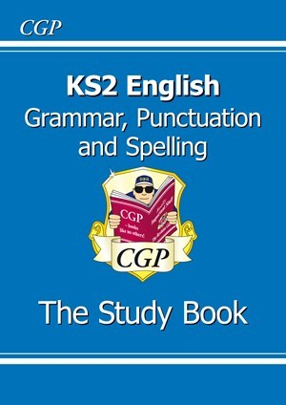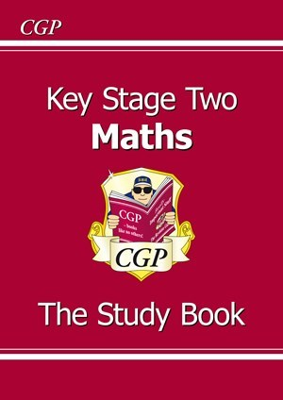 | Year 6 Homelearning Booklet  - Complete the task in your homelearning booklet (given out on Friday)  - This will consist of:  - Spelling – every week  - Reading or Grammar or Maths  - These should not be completed as ‘tests’ or a recall exercise. If you get stuck or don't know something, you need to find it out, e.g. using your Study Book or Googling.  - You could always ask an adult or older sibling to show you how to answer a question.  Remember, the Year 6 adults are always here to help you, too.
Homelearning will be set on Google Classroom. There, you will find all the information you need about the tasks you need to complete and resources to help you with your homelearning. On Tuesdays, I will post the answers to your homelearning. You must mark your work and return your booklet to school so I can check them on Wednesday mornings.
Your Google Classroom username and password are on a sticker on the back of your Reading Diary. No class code is required. If you are prompted for this, you need to check your internet security settings. Further help can be found on the Google Classroom help page or by Googling your problem. There are many useful videos on YouTube.
DURING THIS HALF-TERM
Learning Quest Homelearning
- Your Learning Quest homelearning is all about Antarctica! Before the end of the half-term, you need to create something we can show in our Antarctic Research Station.
- Get creative. This can be a poster, a diorama (a miniature three-dimensional scene), a model, or a PowerPoint presentation; you could even bake! You can do anything about Antarctica!
- Bring your creation to school for the last week of term to share, week beginning Monday 23rd March.

