


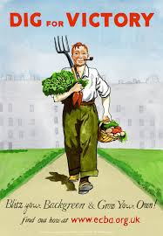

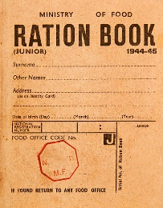
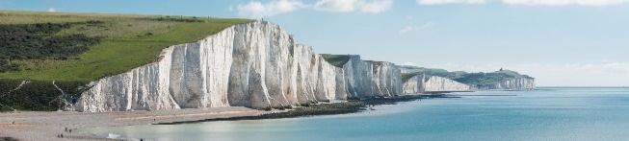
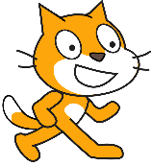
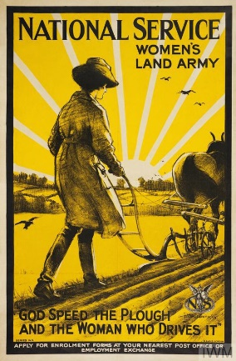
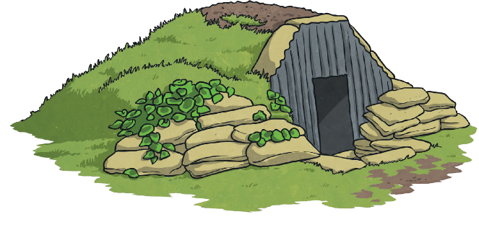
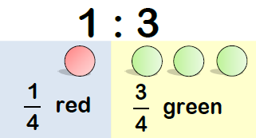

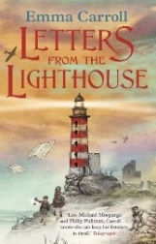

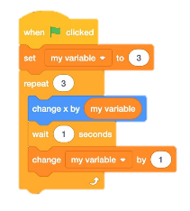
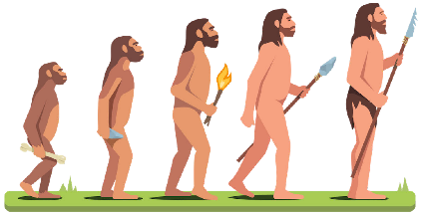

As historians, we will investigate the causes and events leading up to WW2. We will learn about the Battle of Britain and how this affects the overall outcome of the war. We will investigate the impact of the Blitz on people’s lives and our local area and evaluate the effectiveness of primary sources.
Safeguarding
As part of our safeguarding curriculum, we will be looking at ways to stay safe online and how to ask for help if we think we need it. We will consider how a digital personality is developed by online activity and how to use anonymity and privacy settings to prevent people from accessing information.
We will be learning how to keep our bodies and minds safe in our day-to-day life and understand that when things are not going well, this is often temporary.

DAILY
Reading: Rocket Reads recorded in your Reading Diary; make sure you get it signed by an adult.
Maths: TTRS – make sure your heatmap is green. If you know your facts to 12 x 12, start learning your 13 – 19 times tables.
Additional Support: You may be given additional handwriting, times tables, or maths work to complete on an ad hoc basis.
WEEKLY: Set on Fridays to be handed in the following Wednesday
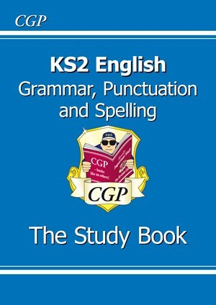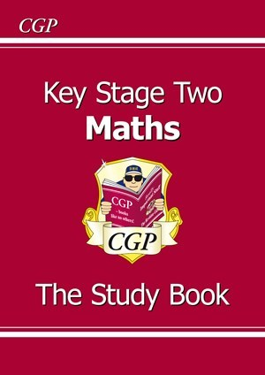 | Year 6 Homelearning Booklet  - Complete the task in your homelearning booklet (given out on Friday)  - This will consist of:  - Spelling – every week  - Reading or Grammar or Maths  - These should not be completed as ‘tests’ or a recall exercise. If you get stuck or don't know something, you need to find it out, e.g. using your Study Book or Googling.  - You could always ask an adult or older sibling to show you how to answer a question.  Remember, the Year 6 adults are always here to help you, too.
Homelearning will be set on Google Classroom. There, you will find all the information you need about the tasks you need to complete and resources to help you with your homelearning. On Tuesdays, I will post the answers to your homelearning. You must mark your work and return your booklet to school so I can check them on Wednesday mornings.
Your Google Classroom username and password are on a sticker on the back of your Reading Diary. No class code is required. If you are prompted for this, you need to check your internet security settings. Further help can be found on the Google Classroom help page or by Googling your problem. There are many useful videos on YouTube.
DURING THIS HALF-TERM
Learning Quest Homelearning
- Before the end of the half-term, you need to create an item we can share in our Museum of World War II
- Get creative. Possible ideas are make a ration book, a propaganda or recruitment poster, a diorama of a significant battle, research spitfires and their significance in the Battle of Britain, create a war time menu to cook, make a map of the showing the Allies and the Axis of Power, learn Morse code, do a make-do-and-mend project, design a medal for a soldier, find out if your family have any artifacts from World War II and research them (ask first please).
- Bring your creation to school to share from the week beginning Monday 3rd February 2025.

