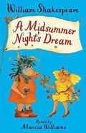
Safeguarding
We will be understanding the impact of online activity on mental, emotional and physical health. Using gardening tools safely.

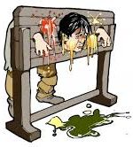


History
As historians, we will be going on a journey through British history to discover how crime and punishment has changed throughout the ages. We will investigate whether changes in society create changes in the kind of crimes that are committed, as well as the ways in which they are punished.

Science
Compare and group everyday materials by their properties, and understand dissolving, mixing, and changes of state. Know that some changes are reversible while others are not, and use comparative and fair test

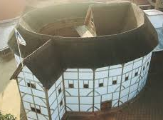

Home Learning
During this half term please complete the following tasks at home:
DAILY
Reading
Make sure that you have a book ‘on the go’ at all times.
You never know when I might ask you about what you are reading currently! This should be at least 5x a week…and this will be checked weekly. Remember… every five reads you will earn a raffle ticket to go into the end of half term prize draw.
WEEKLY
Maths  Check Google Classroom for any bi-weekly learning that has been uploaded.  Use TTRS to ensure that you know all of your times tables and related division facts up to  12 X 12.  Can you increase your score on our weekly times table test? |  | English  Check Google Classroom for any bi-weekly learning that has been uploaded.  Ensure that you can read and write all of the common exception words for your own personal coloured card.  Also learn any spellings or grammar and punctuation learning sent home which will enhance the learning taking place in class.
DURING THIS HALF TERM CHOOSE FROM THE FOLLOWING ACTIVITIES:
Complete these reading tasks:  - Complete reading comprehension activities sent home  - Design a quiz about the book that you have just read.  - Write a character description for the main character in your story. | Learning Quest - History    Imagine you are in charge of the country. Write a set of laws. Include what the punishments would be for breaking your laws!  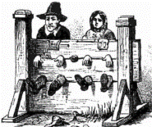 |  | Learning Quest - English    Find out about William Shakespeare and create a presentation/news report about him in a format of your choice.
 | Learning Quest - History    Research and present information about how people who commit crimes are punished in a period of history.  Do you agree with all of our current punishments? |  | Learning Quest – Ideas for family time:  - Visit Shakespeare’s Globe Theatre in London.  - https://www.youtube.com/watch?v=6idyuKJRK8c  - Make a model of Shakespeare’s Globe Theatre. Use any medium that you like from card, paper, Lego or even a cake! If you are lacking inspiration however then use the link below to find one that you can print out, colour and make!  https://www.papertoys.com/images/globe.pdf
Learning Quest - History
Make a wanted poster for a famous real or fictional criminal.
Remember to include their crimes and the reward being offered.


