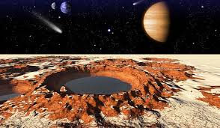
Safeguarding
We will be learning about online safety, in particular, on-line bullying.

In DT we will be learning to use tools safely.

In PSHE we will be focusing on safety and the changing body.

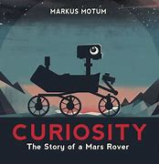
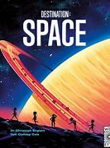

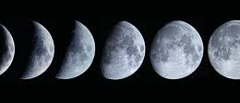
As scientists, we will be learning about Earth and space. We will learn to:
- describe the movement of the Earth and other planets relative to the sun in our solar system.
- describe the movement of the Moon relative to the Earth.
- describe the Sun, Moon and Earth as approximately spherical bodies.
- use the idea of the Earth’s rotation to explain day and night and the apparent movement of the sun across the sky.

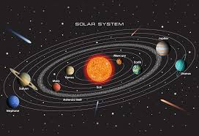

Home Learning Tasks
During this half term please complete the following tasks at home:
DAILY
Reading
Make sure that you have a book ‘on the go’ at all times.
You never know when I might ask you about what you are reading currently! This should be at least 5x a week…and this will be checked weekly. Remember… every five reads you will earn a raffle ticket to go into the end of half term prize draw.
WEEKLY
World Book Week – 2nd March – 6th March  This year is the NATIONAL YEAR OF READING! So we are asking you to throw yourself in to events happening that week.  You could:  - Go through old books and donate ones you don’t want any more to the ‘Book Swap’ event  - Create a ‘Recommended Read’ book list to share with other children in the school  - Thank careful and start to plan your World Book Day character outfit  REMEMBER this DOES NOT need to be a bought costume but can be a homemade outfit or normal clothes with a prop. |  | Maths  Check Google Classroom for any bi-weekly learning that has been uploaded.  Use TTRS to ensure that you know all of your times tables and related division facts up to  12 X 12.  Can you increase your score on our weekly times table test? | English  Check Google Classroom for any bi-weekly learning that has been uploaded.  Ensure that you can read and write all of the common exception words for your own personal coloured card.  Also learn any spellings or grammar and punctuation learning sent home which will enhance the learning taking place in class.
DURING THIS HALF TERM complete at least one reading task and one learning quest task
- Complete at a book review on a book that you have read during this half term.  We will be looking for really good ones to display.  - Write a character profile on a character from a book that you are reading currently.  - Write a fact-file about something you have learnt about Space. | Learning Quest – DT  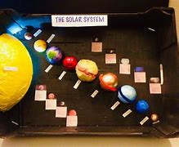  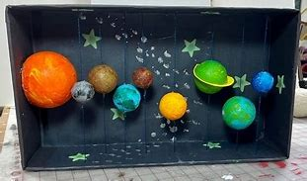  Create a solar system in a box |  | Learning Quest- Creativity  Using ‘Space’ as inspiration, create something of your choice for example – baking, puzzle etc, bring into school and be prepared to talk to the class about it.
 | Learning Quest - science  Keep a ‘moon diary’  Each evening, make an observation of the moon and record what you see. You might like to take photographs or draw pictures to include in your log.  What colour is the moon? What shape is it? What is the weather like? Is the weather affecting what you can see? |  | Learning Quest - computing  Complete this project to enter the Astro Pi Mission Zero challenge and have your code run in space on an Astro Pi computer.  https://projects.raspberrypi.org/en/projects/astro-pi-mission-zero/1

