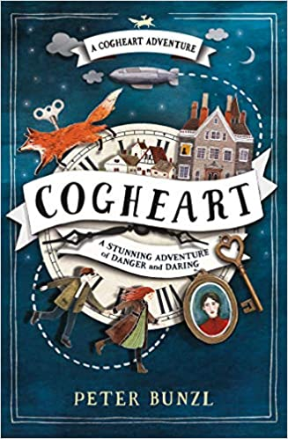
Safeguarding

This half term we will be re-visiting our class charters, class computing charters, and continuing to talk about online safety. We will be linking our safeguarding curriculum to our PSHE learning where we are exploring safety and the changing body.

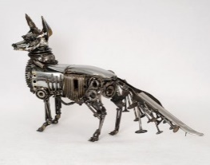
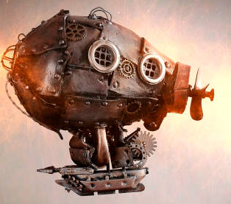

History
As historians we will be discovering the inventions that were created during the Victorian era. We will explore the impact that these inventions have had on our lives today and consider the positive and negative impacts on all aspects of society during the Industrial Revolution.

Outdoor Learning
We will be taking part in weekly outdoor activities linked to the curriculum this half term and taking our learning outdoors whenever we can. We will also be furthering our project on road safety and how to be safe walking to school.
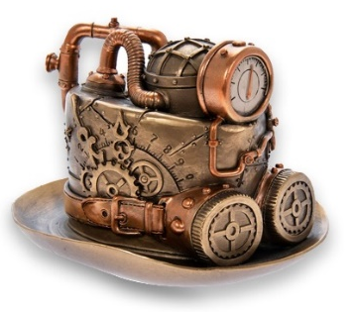

Home Learning Tasks
During this half term please complete the following tasks at home:
DAILY
Reading
Make sure that you have a book ‘on the go’ at all times.
You never know when I might ask you about what you are reading currently! This should be at least 5x a week…and this will be checked weekly. Remember… every five reads you will earn a raffle ticket to go into the end of half term prize draw.
WEEKLY
Class Novel – Cogheart  There may be occasions where you will need to pre-read some chapters at home to ensure the planned learning can take place in lessons. This can be done in many ways i.e. independent, shared reading with a parent/carer or parent/carer reading to you. This will count as one of your five reads! | Maths  Check Google Classroom for any bi-weekly learning that has been uploaded.  Use TTRS to ensure that you know all of your times tables and related division facts up to  12 X 12.  Can you increase your score on our weekly times table test? | English  Check Google Classroom for any bi-weekly learning that has been uploaded.  Ensure that you can read and write all of the common exception words for your own personal coloured card.  Also learn any spellings sent home which will enhance the learning taking place in class.
DURING THIS HALF TERM
Complete at least two of these reading tasks:  - Complete at a book review on a book that you have read during this half term.  We will be looking for really good ones to display.  - Write a character profile on a character from a book that you are reading currently.  - Complete an author study of Peter Bunzl who is the author and illustrator of our class novel. | Learning Quest - History  The inspiration for Cogheart came from reading about the clockmaking geniuses of the 18th and 19th Century who built the first automata and androids (- these are the old fashioned words for clockwork robots, for the word robot was only invented in the 20th century).  Can you find out anything about the following famous early automations online and in books? What were they like, when were they built, and what did they do?  - The Silver Swan by James Cox  - The Digesting Duck by Jacques de Vaucanson  - The Draughtsman by Jaquet-Droz  - The Turk, also known as the Mechanical Turk or Automaton Chess Player by Wolfgang Von Kemplen. | Learning Quest – DT, Science, Art  As part of our learning quest we will be designing our own steampunk inspired ‘mechanimals’. You could design and make your own one. Things to use could be…  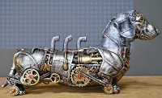  - Metal items – cogs, chains, screws, pipes etc…  - Unwanted watches and jewellery  - Foil food packaging  - Parts of broken toys  - You may find some plastic and cardboard items like kitchen roll tubes and  milk carton tops useful
 | Learning Quest – History / DT  What is a zoetrope? Find out and then have a go at making one of your own. There are lots of websites with ideas or templates. | Learning Quest  Watch a Wallace and Gromit film – How many interesting inventions can you spot?!

