Wellbeing

This half term we will children to understand how their brain works and to support them in developing positive skills and habits to be their very best selves!

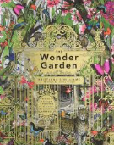

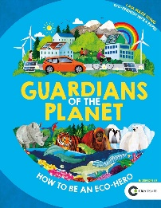
Science

As scientists we will be determining the hardness, and transparency of different materials and link it to their uses. We will then determine the thermal and electrical conductivity of different materials and link this to their uses.
Science

As scientists we will describe how living things are classified into broad groups according to common observable characteristics and based on similarities and differences, including micro-organisms, plants and animals.
We will give reasons for classifying plants and animals based on specific characteristics

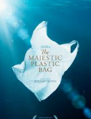

Home Learning Tasks
During this half term please complete the following tasks at home:
DAILY
Reading
Make sure that you have a book ‘on the go’ at all times.
You never know when we might ask you about what you are reading currently!
WEEKLY
Maths  Complete any tasks set Google Classroom. We will learn how to do this in class. | Maths  Use TTRS to ensure that you know all of your times tables and related division facts up to  12 X 12. | Spellings  Ensure that you can read and write all of the common exception words for your year group.  Also learn any spellings sent home.
- Complete a book review on a book that you have read during this half term.  We will be looking for excellent ones to display.  - Read an information text on an environmental issue. Summarise the key messages. | DURING THIS HALF TERM complete at least one of these tasks:
 | Learning Quest - English  Watch ‘The Green Planet’ (available on BBC iPlayer) – create a fact file of something from the episode that interested you!  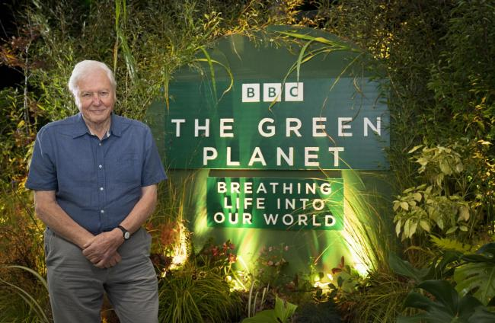 | Learning Quest – Art  Create a piece of art using recycled materials, these can include plastics, crisp packets, yogurt pots/tubes, cardboard etc OR create a piece of art highlighting the issues of plastic pollution.  Be as creative as you like, you could create a sculpture to display in school or a picture to hang.  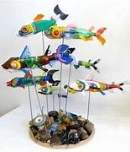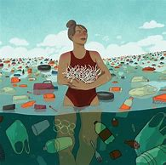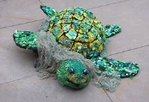
 | 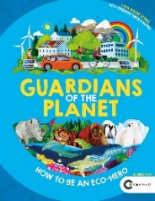  Learning Quest  In what ways are you going to be a ‘guardian of the planet’? What do you already do and what changes will you make at home. | 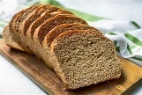  Learning Quest - Science  Cook something that ‘changes the state’ of your raw ingredients. Don’t forget to take pictures before you eat it and send them into school. You could even write your instructions OR an explanation about what happened to your ingredients.

