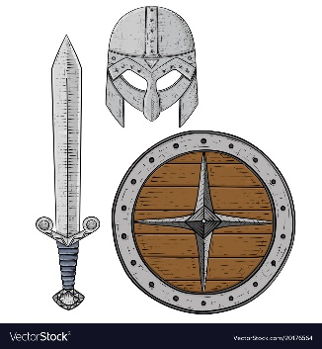

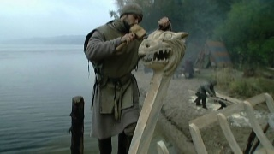

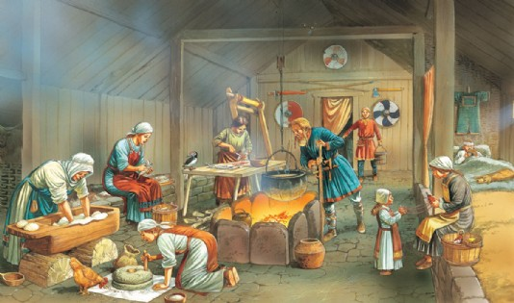

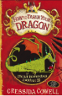
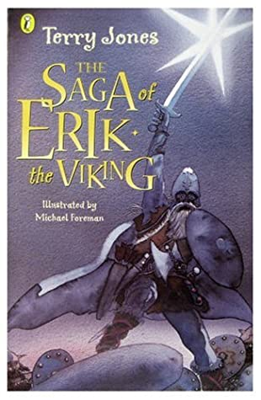

Safeguarding

We will discuss and plan for ways to stay safe in the sun when we are out at breaktimes and on family outings.
We will recap water safety and build on our knowledge on how to stay safe in and around different bodies of water.

As Historians, let us explore this Great British Isle and discover its secrets of the past. Delve deep into ancient mythology and learn all about the Norse Gods and Goddesses. Investigate how the Vicious Vikings became notorious for their dastardly deeds and bloodthirsty raids before discovering the more placid and tranquil life these fearsome people lived.
What will you discover on your explorations…?

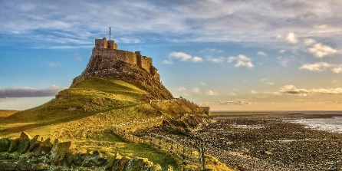
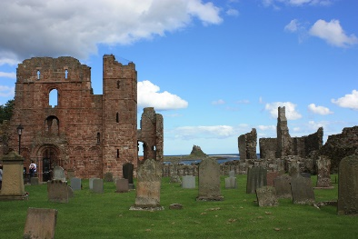

DAILY
Reading
Ensure that you always have a reading book on the go and that you are reading at least 5 times a week for 10-15 minutes.
Mrs Slocombe and I will be looking at the different books you are reading every week and hope you share some great recommendations with us as well!
Reading does not have to be strictly from a book, it could be reading a magazine, online report or even the back of a cereal box… All reading is important!
WEEKLY -
Maths - Times Tables  Use TTRS to ensure that you know all of your times tables and related division facts up to12 X 12.  The following websites may also be helpful  https://www.topmarks.co.uk/maths-games/7-11-years/times-tables  https://www.timestables.co.uk/  Year 4 National Multiplication Check Official Practice website - https://www.timestables.co.uk/multiplication-tables-check/ |  | Spellings  Ensure that you can read and write all of the common exception words for your year group.  Furthermore, practice any spellings sent home via school.  Remember, as well as the home learning sheet, you can complete activities such as:  -Pyramid words -Rainbow words - Ransom words  Any spelling practice will be counted as a read in your reading diary!
DURING THIS HALF TERM PLEASE COMPLETE AT LEAST 3 OF THESE HOME LEARNING TASKS. THESE CAN BE BROUGHT INTO SCHOOL OR CAN BE PHOTOGRAPHED/VIDEOED AND SENT INTO SCHOOL VIA EMAIL:
Complete at least two of these reading tasks:  - Complete a book review on Viking myth, poem or story you have read or during this half term.  We will be looking for those creative ones which show particular effort and perseverance to display both in the classroom and around the school.  - Write a character profile on a character or person from a Viking story, myth or poem – this could be your favourite character, the most ridiculous character or the evillest character. Remember to explain why you have chosen them.  - Summarise a story, myth or poem you have read about in your Viking home learning. You could present this as a PowerPoint or Piccollage (App on iPhone/iPad) or just a poster to then present to the class. | Learning Quest – History  https://www.jorvikvikingcentre.co.uk/about/jorvik-artefact-gallery/  https://www.dkfindout.com/uk/history/vikings/  https://www.natgeokids.com/uk/discover/history/general-history/10-facts-about-the-vikings/  https://www.ducksters.com/history/middle_ages_vikings.php  Click on the links and read about the various aspects of Viking life.  I would like you to create a Fact File about your favourite discoveries which you will present to the class in the final week of term.  You could make and present your findings as:  - A Mood Board  - A PowerPoint presentation  - A large poster  - A short video (if you don’t like speaking in front of people in person)  - You could even try and make a stop-motion animation of your favourite Norse myth. | Learning Quest – DT / History / Art  Can you design your own Viking alter ego?  Spend some time creating and designing your own Viking personality. Do you have a fierce Viking name? What is your weapon of choice? Where have you travelled far from to raid Britain?  Create a character profile for your new Viking personality!  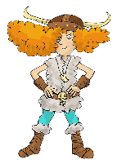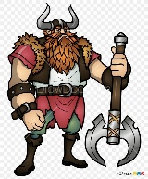
 | Learning Quest - History / Art / DT  Challenge: I would like you to research pictures of Viking shields, swords, axes and helmets. Your task is to try and make a Viking shield, axe, sword or helmet.  It must be:  - Life size to your height.  - Decorated in true Viking style with runes and patterns  If you can, make it from materials other than paper, although paper is fine. Remember to challenge yourself and this is something you can work on over the half term. | Learning Quest – Family Time  Click the link to the following website and read about what the Vikings did for entertainment.  https://primaryfacts.com/82/facts-about-viking-games-and-sports/  I would like you to design and create a board game with a Viking theme that you can play with your family at home or with your friends at school.

