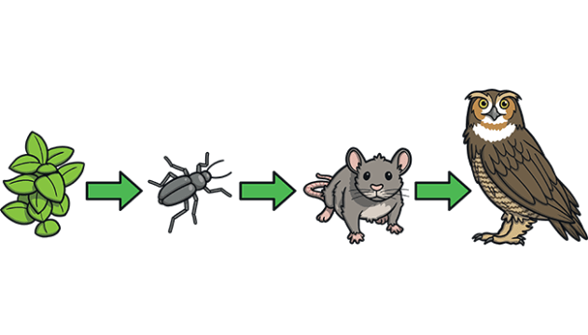
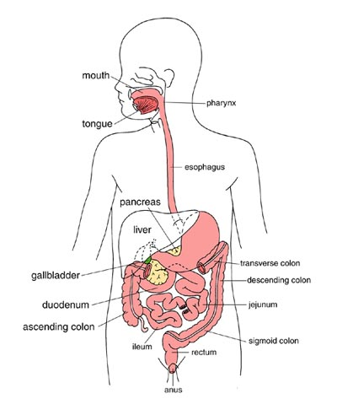

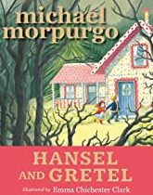
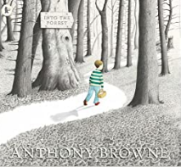
Safeguarding

We will be taking part in the NSPCC PANTS campaign
We will also be linking our safeguarding learning to our computing and discussing how to stay safe online using appropriate search engines and websites.

How do our bodies work? Why do we have to eat? Why do we have to chew our food before we swallow? Why are our teeth all different?
In this Learning Quest, we will discover the incredible journey food takes through our bodies making us strong and healthy and understand the impact our diet has on our bodies.
We will explore food chains around the world. Looking at producers, prey and predators, we will answer the question of who eats whom in these different food chains!
Get yourself ready Scientists! Let us explore and understand one of the life processes of humans and animals!

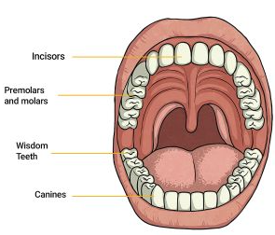

DAILY
Reading
Ensure that you always have a reading book on the go and that you are reading at least 5 times a week for 10-15 minutes.
Mrs Slocombe and I will be looking at the different books you are reading every week and hope you share some great recommendations with us as well!
Reading does not have to be strictly from a book, it could be reading a magazine, online report or even the back of a cereal box… All reading is important!
WEEKLY -
Maths - Times Tables  Ensure that you are using TTRS regularly to practice your times table facts up to 12 x 12!  The following websites may also be helpful  https://www.topmarks.co.uk/maths-games/7-11-years/times-tables  https://www.timestables.co.uk/  Year 4 National Multiplication Check Official Practice website - https://www.timestables.co.uk/multiplication-tables-check/ |  | Spellings  Ensure that you can read and write all of the common exception words for your year group. Furthermore, practice any spellings sent home via school.  Remember, as well as the home learning sheet, you can complete activities such as:  -Pyramid words -Rainbow words - Ransom words  Any spelling practice will be counted as a read in your reading diary!
DURING THIS HALF TERM PLEASE COMPLETE AT LEAST 3 OF THESE HOME LEARNING TASKS. THESE CAN BE BROUGHT INTO SCHOOL OR CAN BE PHOTOGRAPHED/VIDEOED AND SENT INTO SCHOOL VIA EMAIL:
Reading tasks:  - Complete a book review on a Non-Fiction (information) book about nature, animals or the human body.  We will be looking for those creative reviews that show particular effort and perseverance to display both in the classroom and around the school.  - Write your own fact page using the knowledge you have gained reading a non-fiction book. Remember to use a catchy title, subheadings to organise your work and add some ‘Fun Fact’ bubbles.  - Summarise a story, myth or traditional tale you have read during your reading for pleasure home learning. You could present this as a PowerPoint or PicCollage (App on iPhone/iPad) or just a poster to then present to the class. | Learning Quest – Science  Look at the Science Home Learning Menu. Choose at least 3 activities to complete over this half term.  - Build a digestive system model – you can either build it from plasticine, rolled up clothes, sweets or just cut out bits of paper. If you are adventurous, you could try bottles and tubes! Just remember to label the different parts of the system.  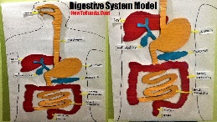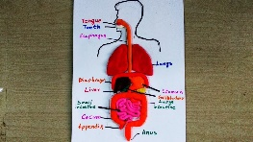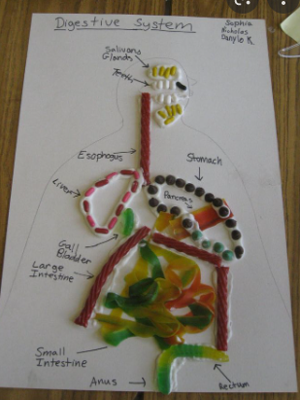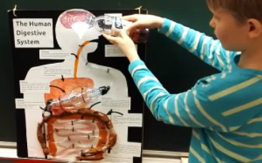  - Use the link to explore food chains https://www.bbc.co.uk/bitesize/topics/zx882hv/articles/z3c2xnb then play the ‘Food Chain Game’ using this link https://www.sheppardsoftware.com/science/animals/games/food-chain/  Can you now make your own food chain?  - Using the links below to explore the rest of the human body. Create a poster that includes your most fascinating finds.  https://thehumanbodygame.co.uk/  https://kidshealth.org/en/kids/center/htbw-main-page.html  - Can you build your own habitat and create your own creatures there? What would the food chain look like in your world? Make a leaflet informing visitors about your world.  - Family time! Sit down together and watch some of the BBC’s most beautiful, informative programs, e.g. ‘Seven Worlds, One Planet’, ‘Planet Earth’, ‘The Green Planet’, ‘Blue Planet’ and ‘Our Changing World’. Discuss images that amaze and astound you How many habitats have you seen? Did you spot any food chains? What questions do you have about the things you see? Remember these questions or write them down and see if you can answer them after the program. What interesting facts have you discovered? Is there anything you would like to see or anywhere you would like to go when you are older? Write a short summary about your discoveries.

