
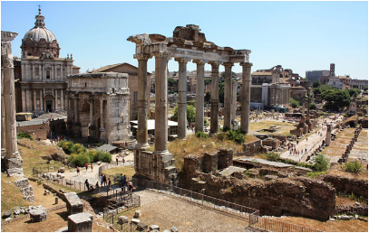
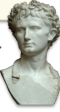

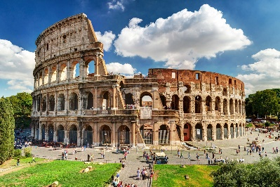

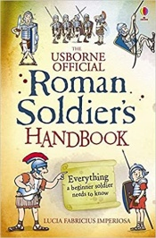
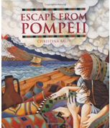

Safeguarding
We will build on our knowledge about Online Safety and discuss ways to write email safely and appropriately.
We will examine ways to create Powerful Passwords to keep ourselves safe online.
We will be discussing health, wellbeing and citizenship in our PSHE learning.
We will complete activities during Internet Safety Week.

As Historians, we will explore what life was like in Britain just before the Roman invasion and then the impact these legions had on everyday life for the British.
What is an emperor?
What happened at Pompeii?
What was daily life like as a Roman?
Can we see any Roman influences in our lives today?

Let’s travel through time together to unravel the mysteries of the Roman Empire…

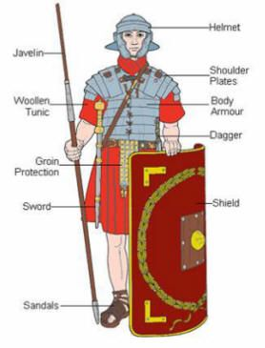
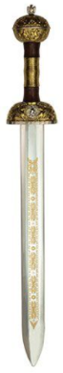

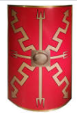

DAILY
Reading
Ensure that you always have a reading book on the go and that you are reading at least 5 times a week for 10-15 minutes.
Mrs Slocombe and I will be looking at the different books you are reading every week and hope you share some great recommendations with us as well!
Reading does not have to be strictly from a book, it could be reading a magazine, online reports or even the back of cereal box… All reading is important!

WEEKLY -
Maths  Use TTRS, Topmarks ‘Hit the Button’ and other games to ensure that you know all of your times tables and related division facts up to 12 X 12. Belwo are some helpful websites!  https://www.topmarks.co.uk/maths-games/7-11-years/times-tables  https://www.timestables.co.uk/  http://www.primaryhomeworkhelp.co.uk/maths/timestable/interactive.htm  Year 4 National Multiplication Check Official Practice website - https://www.timestables.co.uk/multiplication-tables-check/ |  | Spellings  Ensure that you continue practicing the year 4 common spelling words (which are in reading diaries). Remember that these count towards your reads for the week!  Learn any spellings sent home.
DURING THIS HALF TERM PLEASE COMPLETE AT LEAST 3 OF THESE HOME LEARNING TASKS. THESE CAN BROUGHT IN TO SCHOOL OR CAN BE PHOTOGRAPHED/VIDEOED AND SENT INTO SCHOOL VIA EMAIL:
Reading tasks:  - Complete a book review on a Non-Fiction (information) book you have read during this half term.  We will be looking for those creative reviews which show particular effort and perseverance to display both in the classroom and around the school.  - Write your own fact page using the knowledge you have gained reading a non-fiction book. Remember to use a catchy title, subheadings to organise your work and add some ‘Fun Fact’ bubbles.  - Summarise a story, myth or poem you have read during your reading for pleasure home learning. You could present this as a PowerPoint or PicCollage (App on iPhone/iPad) or just a poster to then present to the class. | 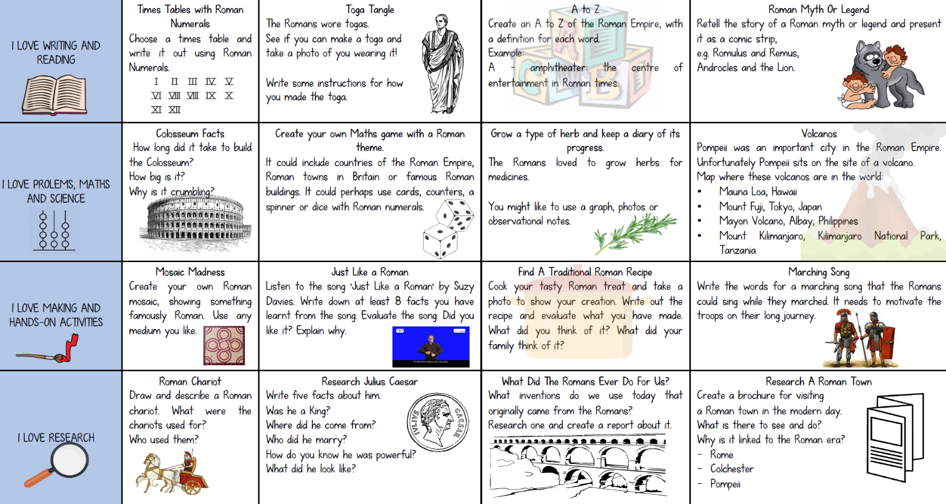  Learning Quest  –History  Look at the  Roman Home  Learning Menu.  Choose at least  3 activities to  complete over  this half term.
Learning Quest – Geography
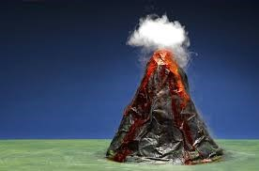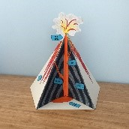Look at the Geography Learning Menu.

Choose at least 3 activities to complete over this half term.

- Build a Diorama of a Volcano: use recycled materials from home to create a 3D model of a volcano

- Research earthquake and complete 1 or more of the following:
- Design a poster with tips on how to stay safe during an earthquake.
- Write a set of instructions for the school on what we should do to stay safe if we ever experience an earthquake

- Using the link below, can you make your own tornado/earthquake/tsunami siren?
https://musiclab.chromeexperiments.com/Song-Maker

- Watch some episodes of NewsRound or local news broadcasts. Watch the anchor men and women. How do they talk and present themselves?
Can you write yourself a script and record yourself giving a breaking news report on your chosen natural disaster? Could you work together with a friend – one at the scene and one in the studio? Record and upload to Dojos.

