Safeguarding
We will refresh our knowledge about being safe and respectful online and about Road and Fire Safety. Safety around fireworks and bonfires.

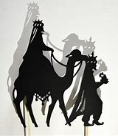

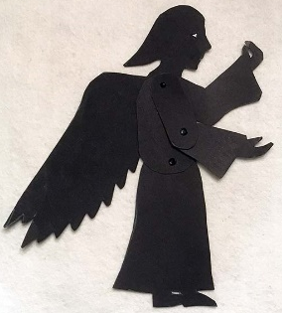
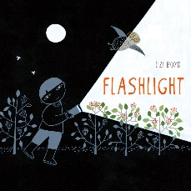
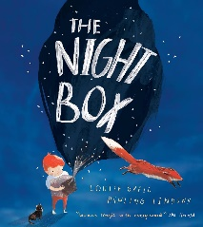

As Scientists, lets investigate how light travels and reflects off different objects as well as how shadows are formed and what can affect the size and shape of them. Let’s investigate different animals and which animals thrive at night. This will all lead up to our final big shadow puppet performance!

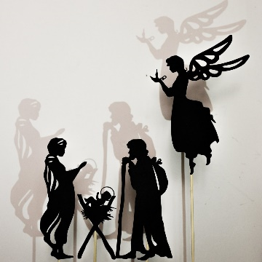
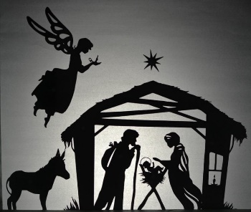

Home Learning Tasks During this half term please complete the following tasks at home:
DAILY
Reading
Make sure that you have a book ‘on the go’ at all times.
Please record your reading in your reading diary. Make sure you are reading at least 5 times a week.
WEEKLY
Maths    5 x a week use TTRS to ensure that you know all of your times tables and related division facts up to 12 X 12. Begin by focusing on 2, 3, 4, 5 and 10s. | Practise the following skills:  - I can quickly add and subtract numbers to 20.  - I can remember my 2, 5, and 10 times tables.  - I can double and halve numbers to 20.  - I can count forwards and backwards in 1s, 2s, 3s, 5s, and 10s.  - I can spot tens and ones in a number and add or subtract tens.  - I can solve simple number problems in my head. |  |  | Spellings  Ensure that you can read and write all of the KS1 common exception words.  Furthermore, learn any spellings sent home.
DURING THIS HALF TERM
 |  | Choose at least 3 of these to complete:
Complete at least two of these reading tasks based on a book you have enjoyed reading:  - Draw the story – Draw a picture of your favourite part of the book and write 1–2 sentences about it.  - Character diary – Pick a character and write a short diary entry from their point of view about something that happened in the story.  - Word collector – Find 5 interesting or new words in your book, write them down, and explain what they mean in your own words.  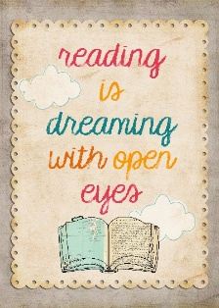  - Story map – Draw a map of where the story happens and label the key locations.  - Comic strip – Retell a scene from the story  as a comic with pictures and speech bubbles.  - Book review – Write 2–3 sentences  saying what you liked about the book  and why you would recommend it. |  | Shadow Hunt: Go on a walk around your home or garden and take photos or draw pictures of different shadows you can find. | Shadow Diary: Track your shadow at different times of the day and record how its size and direction change.
 |  | Mirror Magic: Use a small mirror to reflect sunlight around a room and record how you can change the direction of the light beam. | Shadow Puppet Design: Design your own animal shadow puppet, thinking about the shape and details that will show up best in a shadow.
 |  | Light and Dark Animal Research: Choose a nocturnal animal to research and create a fact file explaining how it survives at night. | Transparent or Opaque Test: Collect different materials and test which ones let light through, then sort them into transparent, translucent, and opaque groups.
 |  | Create a Mini Shadow Theatre: Make a small stage using a cardboard box and white paper, ready for your shadow puppets. | Reflective Hunt: Find and list objects in your home that reflect light well (like a spoon or foil) and explain why.
 |  | Torch Experiment: Use a torch to test how moving the light closer or further away from an object changes the shadow size. | Shadow Puppet Performance: Put on a short shadow puppet show for your family, using what you’ve learned about light and shadows to create clear effects.

As you complete each task bring it into school and add it to your learning quest book.

