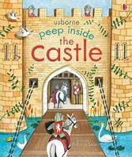
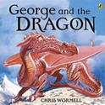

Safeguarding
We will build our knowledge of staying safe online and explore how to treat others both online and in person.

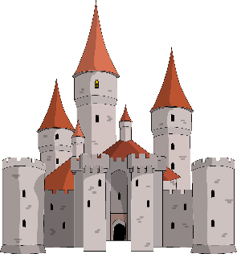

As Historians…
We will be comparing life now to life inside a medieval castle! We will investigate the different roles people had in castles, the clothes they wore and the food they ate. We will be looking into the past to investigate how life differs from today. This will fuel our writing as we create an informative piece on life inside a castle in English.

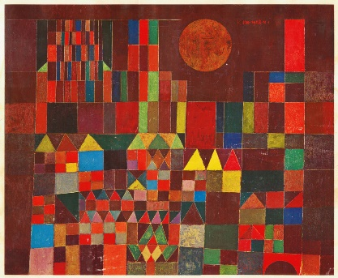
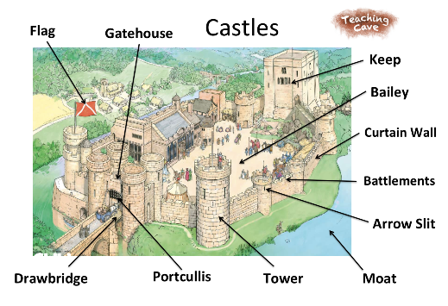


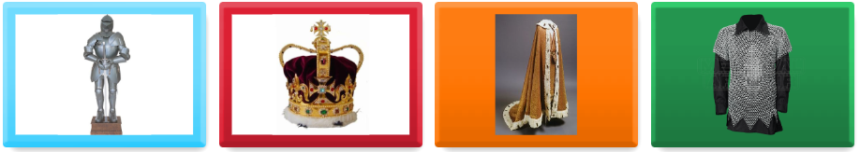

Home Learning Tasks
During this half term please complete the following tasks at home:

DAILY
Reading
Reading books will be changed on Mondays and Library books on Tuesdays.
Daily reading is so important and a note in the reading diary to discuss strengths and difficulties would be very helpful!

WEEKLY
Maths  Involve counting into daily life. Practice comparing different amounts. Ensure that you can recognise the numbers up to 10 and their spelling.  Numbots – for practising fluency and subitising. | Spellings  Ensure that you can read and write all of the common exception words for your year group.  Also learn any spellings sent home.
DURING THIS HALF TERM – choose at least 1 of these and complete over the half term
Learning Quest – Write a story from the viewpoint of someone in a castle e.g.  - A servant  - A King/Queen  - A Prince/Princess  - George  - The Dragon | Learning Quest – Create a cardboard castle with a working drawbridge following the tutorial on the English Heritage YouTube Channel  How To Make A Cardboard Castle  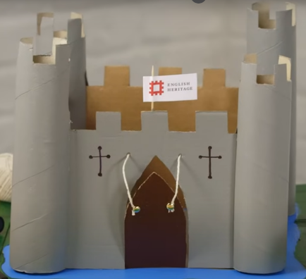
Learning Quest – Design and draw your own castle. What would it be made of? Would you have any knights? Would there be a dragon nearby?


