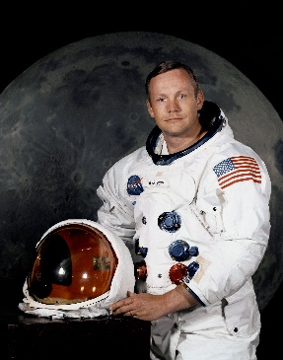
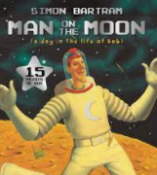

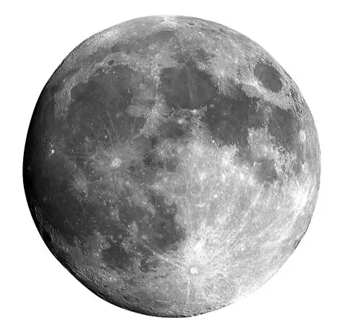

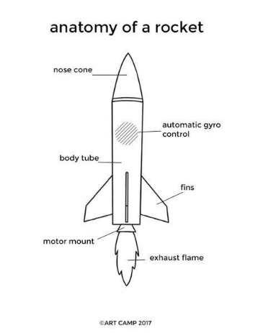
Can I go to the Moon?
Safeguarding
We will build our knowledge of staying safe online and online friendships, including sharing information online and via our devices.

As historians, we will explore how incredible events from the past have shaped the world we live in today. Through interviews, timelines, and fascinating sources, we will investigate our enquiry question: “What was the Moon landing?” We will discover how this remarkable moment in history captured the imagination of millions around the world and learn about the bravery and determination of astronaut Neil Armstrong as he took his first historic steps on the Moon.

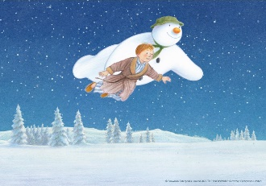
Outdoor Learning
We will be spending lots of time outdoors. We will use natural resources to support maths lessons.

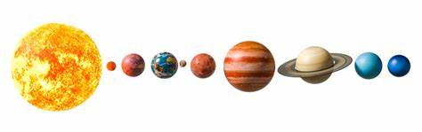

Home Learning Tasks
During this half term please complete the following tasks at home:

DAILY
Reading
Reading books will be changed on Mondays
Daily reading is so important and a note in the reading diary to discuss strengths and difficulties would be very helpful!

WEEKLY
Maths  Involve counting into daily life. Practice comparing different amounts. Ensure that you can recognise the numbers up to 10 and their spelling.  Explore number bonds within 5 and 7. | Spellings / Writing  Ensure that you can read and write all of the common exception words for your year group.  Ensure that you can write a sentence using a capital letter, finger spaces, and a full stop.
DURING THIS HALF TERM – choose at least 2 of these and complete over the half term
Learning Quest – Can you create a postcard for Bob’s day on the moon? What would you want to ask him? | Learning Quest – Research the Moon Landing and Neil Armstrong using the following links. Create a poster about the interesting facts you find!  Neil Armstrong facts for kids - National Geographic Kids  Who was the astronaut Neil Armstrong? - BBC Bitesize  Neil Armstrong - Kids | Britannica Kids | Homework Help  When was the first moon landing? - BBC Bitesize  The Moon Landing – National Geographic Kids
Learning Quest – Follow the link below to The Craft Train website and create a Solar System Sponge art!

Solar system art - The Craft Train

