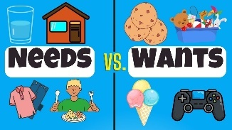
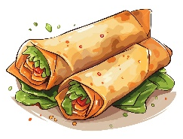
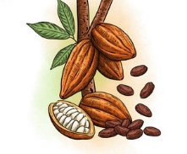
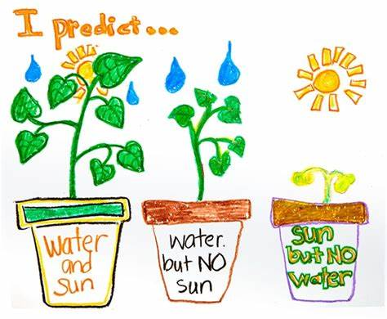
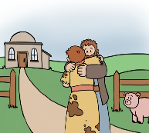


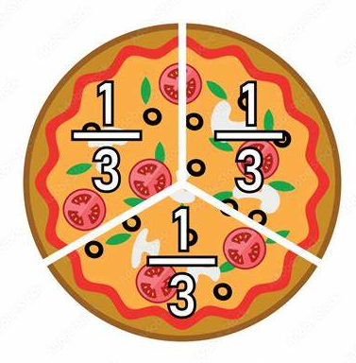
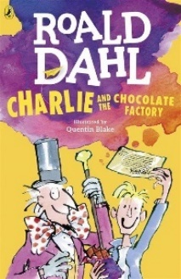
Visitor
This half term we are really excited to take part in a chocolate workshop. We will design and make our own chocolate pizza, selecting from a variety of sweet toppings and getting to taste it afterwards.
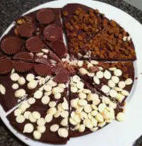
Outdoor Learning
Year 2 will be hoping for nice weather as we’ll be planting some salad and other veggies to hopefully harvest for our healthy wraps!
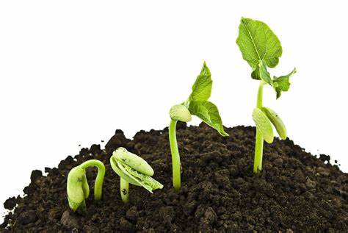
Safeguarding
Learning how to stay safe when using computers and the internet form the basis of this e-safety session. We will talk about asking for permission, keeping personal information private, and knowing who to trust.

Reading  Golden Ticket reading challenge.  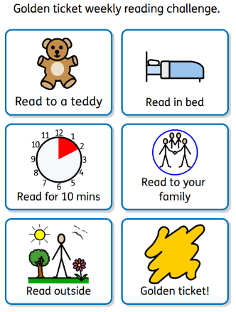  Complete 5 of these challenges each week to earn your golden ticket. Record this in your reading diary. One lucky ticket holder, drawn at random, will win a special treat! | Maths  🟡 Outdoor Maths: Number Jump Trail  - Draw a number line outside from 0 to 20.  - Place your marker on any number between 1 and 20.  - Roll the dice (or pick a number card).  - Decide: add or subtract that number.  - Jump your marker forward (for adding) or backward (for subtracting).  - Say the sum out loud and write it down.  - e.g. “14 − 5 = 9” or “6 + 3 = 9”  - Repeat for 10 turns!  - Login to TTRS or Numbots to help improve or secure fundamental maths skills and practise your 2s, 5s and 10s times tables.
Spelling:
The next set of Year 2 common exception words to learn are: every, everybody, even, great, break, steak, pretty, beautiful, after, fast, improve, prove and move. Here are some games and activities you could use to help you practise.
🐾 Water Writing
- Use a paintbrush and a bucket of water to “paint” words on a fence, pavement, or wall (ask first!)
🫧 Spelling bubbles - you will need some bubble solution and a wand
- Blow some bubbles
- Pick one of your words
- Spell it out loud, popping a bubble for each letter
🎯 Target Toss Spelling – you will need buckets, bowls, or hoops (numbered or labelled), beanbags or balls
- Pick 5 words and write them in a numbered list.
- Label each bucket or hoop with a number (e.g., 1–5).
- Toss the beanbag or ball into a target.
- Whatever number it lands in, spell that word aloud
DURING THIS HALF TERM – choose 2 of these to complete (obviously, you can do more !)
Learning Quest – English  Imagine you're working for Willy Wonka and you have been asked to come up with a brand new chocolate bar or sweet to sell in his factory! Write a description of your creation. Use this WAGOLL to inspire you!  The "Fizzy Berry Surprise" is a magical chocolate bar with a soft, creamy chocolate exterior and a surprise inside! When you take a bite, it fizzes and pops in your mouth like a mini explosion of fruity fun. The chocolate is filled with berry-flavoured goo and tiny fizzy candies that make your taste buds dance. It's wrapped in a shiny purple wrapper with a bright yellow swirl on the front. It’s perfect for children who love surprises and fun flavours! |  | Learning Quest – Art  Create an art design of your chocolate bar or sweet.  Be as detailed as you can!  Show:  The wrapper design (does it have a special logo or colours?).  The shape and size of the chocolate or sweet.  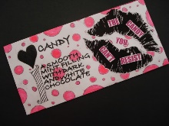  What’s inside it or what makes it special!  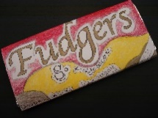  Fizzy Berry Surprise – The chocolate that pops and zings!
Learning Quest – Maths Fraction Action!  Go on a fraction hunt around the house to find different items or situations that show fractions in action. Here are a few ideas:  Kitchen Hunt:  - Find 1/2 of a fruit (like an apple, banana, or orange).  - Find 1/4 of a pizza or any food item you can cut into 4 parts.  - Find 1/2 of a sandwich. How does it look when cut in half?  - Find a measuring cup with 1/4 of a cup filled. (Maybe in baking or cooking!)  🧸 Toy Hunt:  - Find 4 toys. How many toys is 1/2 of 4?  - Find 6 toys. What is 1/3 of 6  Write down or draw what they find. They can also take pictures of their discoveries and send in for our home learning display. |  | Learning Quest – Science  Grow a plant from a seed or bulb at home and make a note of the different stages of its life cycle.  Look out for these stages:  - Seed/Bulb  - Sprout  - Seedling  - Growing Plant  - Flowering/Mature Plant  For each stage, you could take a photo, draw a picture or write a sentence to explain what is happening.  

