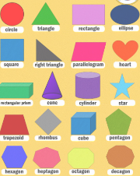
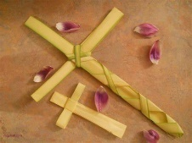
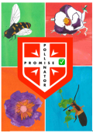
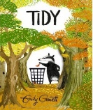
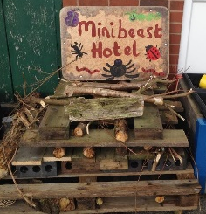
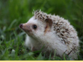
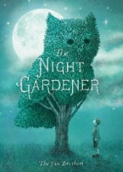
Safeguarding
We will continue to build our skills in recognising when we feel unsafe and what action we can take. We will also look at how we keep safe in other environments, including our school trip to Dell Quay in Chichester Harbour.

Christian Values
In our second English text driver, Tidy by Emily Gravett, Y2 will build their understanding of fellowship and how to take action in order to make a difference.

Reading  Daily reading  - Now that we are halfway through Year 2, it is really important to establish a daily routine for reading in preparation for Key Stage 2. Remember you can include sharing your library books and bedtime stories as part of your five reads. | Maths    - TTRockstars - aim to practise your 2, 5 and 10x tables each day. We will practise these regularly in school too, but the more you practise, the more confident and fluent you will become.
Spelling:
The next Y2 common exception words to learn are:
last, past, father, class, grass, pass, plant, path, bath, sure, who, sugar.

We will also continue to practice last half term’s words, which are:
every, everybody, even, great, break, steak, pretty, beautiful, after, fast, improve, prove move.

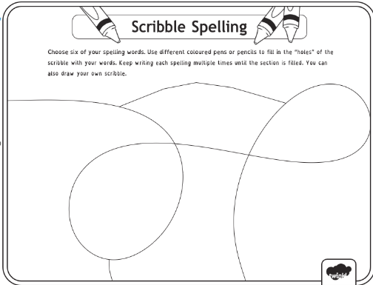
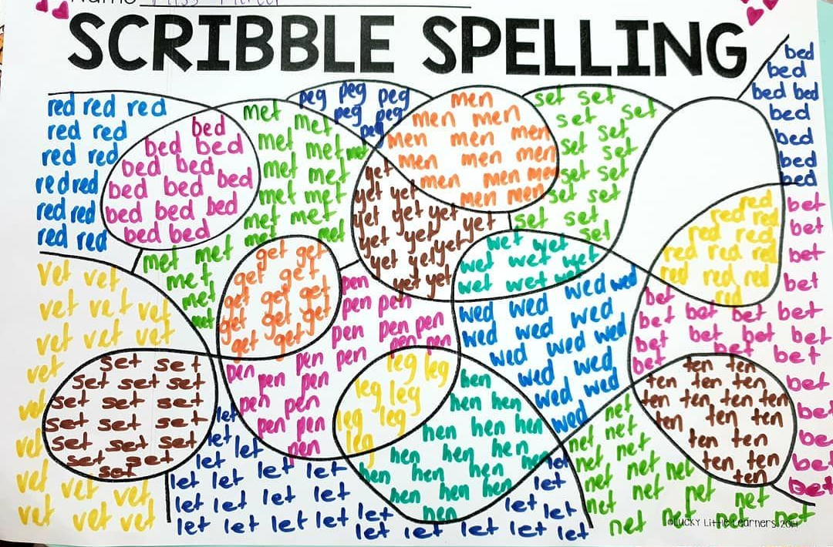
Try using the scribble spelling strategy pictured here. You can ask for blank formats to take home!

DURING THIS HALF TERM – choose 2 of these to complete (obviously, you can do more !)
Channel your inner David Attenborough, Steve Backshall or Hamza Yassin and get passionate about protecting nature!
- International Polar Bear Day –27th February 2026
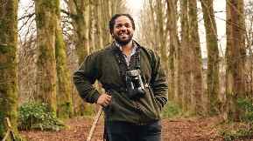
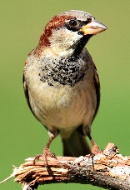


- National Panda Day –16th March 2026
- World Sparrow Day –20th March 2026
- World Frog Day - 20th March 2026
- International Seal Day –22nd March 2026
- World Aquatic Animal Day –3rd April 2026
Learning Quest – Science Nature Diary  Keep a diary of what you see in your garden or out on a walk (plants, birds, insects) over a weekend.  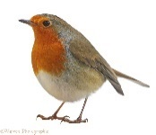  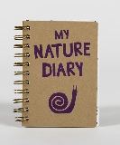 | Learning Quest – Art Make a Habitat Collage  - Pick a habitat – Rainforest, desert, ocean, or woodland.  - Find pictures – Cut from magazines, print, or draw animals and plants.  - Arrange your pictures – Place them on paper or cardboard  - Glue them down – Stick everything in place.  - Decorate – Add extra details like the sun or clouds.  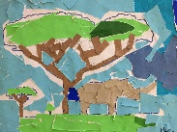
Learning Quest – Maths Be a shape hunter  Look around you either in your home or your local environment. What shapes can you find?  Take photos or draw pictures of the shapes that we can find around us.  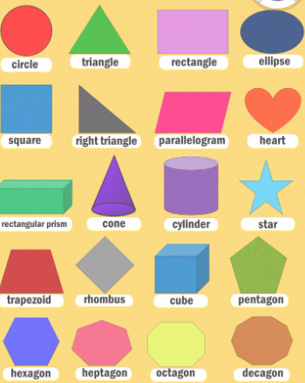 | Learning Quest – Home Litter Pick Challenge! 🗑️🌍  Help keep your home area clean by collecting and sorting litter!  - Find a safe place – Your garden, street, or local park (with an adult).  - Wear gloves – Stay safe while picking up litter.  - Collect litter – Use a bag to gather rubbish you find.  - Sort it – Put recyclables (like plastic and paper) in the recycling bin.  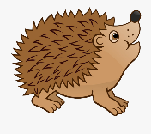  - Record your findings – Make a tally chart of the types of litter you find (e.g., plastic, paper, cans).  You can borrow litter pickers from school to help you in your challenge!  Send in a photo to admin@st-albans.hants.sch.uk  #pick4prickles

