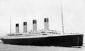
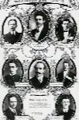

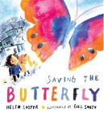
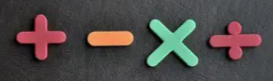
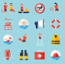
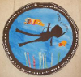
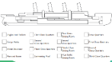

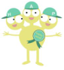

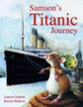
Safeguarding
We will learn key water safety skills like staying close to adults, spotting warning signs and never swimming alone. We’ll also cover sun safety, including wearing hats, using sunscreen and staying hydrated.
Trip
We are very excited to go on a trip to the Titanic museum in Southampton. We will have a chance to see the artefacts on display, have a workshop to consolidate our knowledge of the event and even try on outfits from the time period.

Outdoor Learning
Year 2 will continue to take care of our school grounds. We will weed, plant seeds, water and nurture our growing plants.

Reading  Keep your reading afloat with a Titanic challenge! It is an expectation that you read 5 times a week at home.  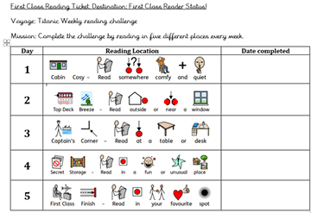 | Maths  Know the 2, 5 and 10 x tables and division facts by the end of Year 2 to be ready for KS2. Play this game to help you.  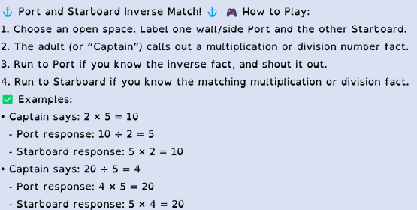
Spelling:
The final set of Year 2 common exception words will be sent out at the start of the half term. The list will also show the words that your child still needs to practise from the previous half terms. The more confident they are with the Year 1/2 words, the more ready they will be to move on to KS2.
🐾 Water Writing
- Use a paintbrush and a bucket of water to “paint” words on a fence, pavement, or wall (ask first!)
🫧 Spelling bubbles - you will need some bubble solution and a wand
- Blow some bubbles
- Pick one of your words
- Spell it out loud, popping a bubble for each letter
🎯 Target Toss Spelling – you will need buckets, bowls, or hoops (numbered or labelled), beanbags or balls
- Pick 5 words and write them in a numbered list. Label each bucket or hoop with a number (e.g., 1–5).
- Toss the beanbag or ball into a target.
- Whatever number it lands in, spell that word aloud
DURING THIS HALF TERM – choose 2 of these to complete (obviously, you can do more !)
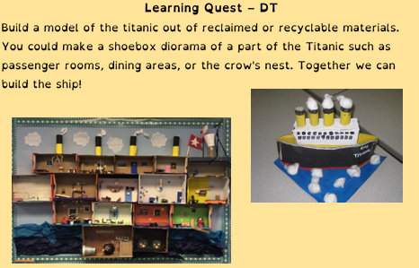 |  | PSHE  Make a poster either about sun safety or water safety.  Include the key tips that we teach you at school.  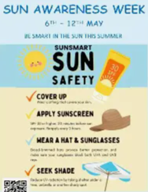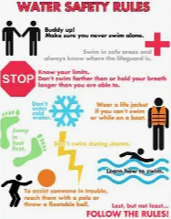
Learning Quest – History  Create a fact file about the Titanic. You could include what it was like for the different classes onboard, the clothing they wore in 1912, the events leading up to the sinking and any other interesting facts that you come across.  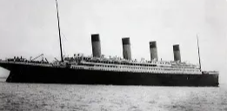 |  | Learning Quest – Art  Practise your sketching skills by drawing something that interests you.  Remember to start off by keeping your pencil strokes very light so you can easily make changes. You can keep it black and white or add colour with pencils, paint or chalks.  

