
YEAR 6 LONG TERM OVERVIEW PLANNING with:

Key Driver Texts and Parallel texts for English identified and Key Wider Curriculum Subject Drivers

 | Autumn 1 | Autumn 2 | Spring 1 | Spring 2 | Summer 1 | Summer 2
 | Quest Question  How can we become more sustainable?  FELLOWSHIP/ LOVE  WINDOW - BEAUTY  Key Drivers  Geography: Human Geography: types of settlement and land use, economic activity including trade links, and the distribution of natural resources including energy, food, minerals and water  Text Driver A:  The Last Wild By Piers Torday  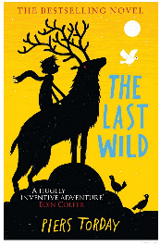  Parallel texts:  The Last Wild: Books 1-4 by Piers Torday; Where the River Runs Gold by Sita Brahmachari; The Wild Folk by Sylvia V Linsteadt  Text Driver B:  Pandora Discovered (Film Unit)    Parallel texts:  His Dark Materials series by Philip Pullman; The ‘Strangeworlds’ Travel Agency by L.D. Lapinski; Into the Sideways World by Ross Welford | Quest Question  Where does our light come from?  LOVE  SELF-MIRROR  Key Drivers  History: a non-European society that provides contrasts with British history – one study chosen from: early Islamic civilization, including a study of Baghdad c. AD 900  Text Driver A:  Hamlet by Andrew Matthews  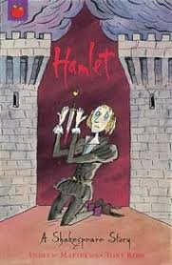  Parallel texts:  A Stage Full of Shakespeare Stories by Angela McAllister & Alice Lindstrom; Michael Morpurgo’s Tales from Shakespeare by Michael Morpurgo  Text Driver B:  Firebird by Saviour Pirotta  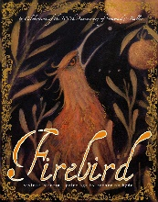  Parallel texts:  The Snow Queen by Hans Christian Andersen; Inkheart by Cornelia Funke  Text Driver C:  The Night Mail by WH Auden – Poetry  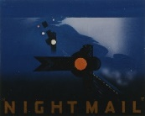  Parallel texts:  1936 GPO Film Classic; The Tyger by William Blake; Jabberwocky by Lewis Carroll; The King's Breakfast by A.A. Milne | Quest Question  What are we hiding from?  COURAGE  DOOR-OTHERS  Key Drivers  History: a study of an aspect or theme in British history that extends pupils’ chronological knowledge beyond 1066 (WW2)  Text Driver A:  Letters from the Lighthouse by Emma Carroll  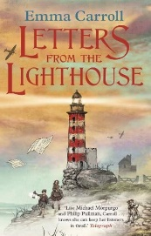  Parallel texts:  The Valley of Lost Secrets by Lesley Parr; Our Castle by the Sea by Lucy Strange; When the Sky Falls by Phil Earle  Text Driver B:  Alma (Film Unit)  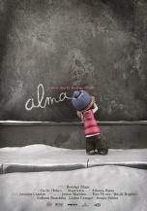  Parallel texts:  The Spirit Snatcher by Cat Gray; The Beast and the Bethany by Jack Meggitt-Phillips & Isabelle Follath; Seaglass by Eloise Williams | Quest Question  What journeys shall we go on?  FELLOWSHIP  SELF -MIRROR  Key Drivers  English: Shackleton’s Journey by William Grill  Text Driver A:  Shackleton’s Journey by William Grill  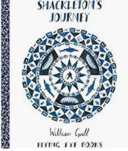  Parallel texts:  The Polar Bear Explorers’ Club by Alex Bell & Tomislav Tomic; Race to the Frozen North by Catherine Johnson & Katie Hickey; Shackleton 100  Text Driver B:  The Three Little Pigs – The Guardian Advert  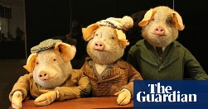  Parallel texts:  A modern version of a traditional tale; Twisted tales; The House with Chicken Legs by Sophie Anderson; Inside the Villains by Clotilde Perrin | SATS Revision and Preparation for Writing Moderation | Quest Question  What have we learnt from the Ancient Greeks?  FELLOWSHIP/COURAGE  BEYOND -CANDLE  Key Drivers  History: A study of Greek life and achievements and their influence on the Western world.  Text Driver A:  Greek Myths by Marcia Williams  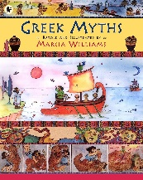  Parallel texts:  Myths and Legends by Anthony Horowitz; Who Let the Gods Out by Maz Evans; Mythologica; Myths Monsters and Mayhem by James Davies
RE | King  What kind of King was Jesus?  (UC Kingdom of God Unit 2B.8) | Messiah  Was Jesus the Messiah?  (UC Incarnation Unit 2B.4) | Origins  Are creation and science contradictory or complimentary?  (UC Creation Fall Unit 2B.2) | Resurrection  What difference does the resurrection make to Christians?  (UC Salvation Unit 2B.7)  PC – The Night before the Resurrection, Manila, the Philippines, No 15 | Ritual (Special)  Wudu and Eid Al Fitr  (Islam at KS2 - RE 040) | Peace  Islam  (Islam at KS2 - RE 040)
SAFEGUARDING
SCIENCE | Electricity  Associate the brightness of a lamp or the volume of a buzzer with the number and voltage of cells used in the circuit.  Compare and give reasons for variations in how components function, including the brightness of bulbs, the loudness of buzzers and the on/off position of switches.  Use recognised symbols when representing a simple circuit in a diagram | Light  Recognise that light appears to travel in straight lines.  Use the idea that light travels in straight lines to explain that objects are seen because they give out or reflect light into the eye.  Explain that we see things because light travels from light sources to our eyes or from light sources to objects and then to our eyes.  Use the idea that light travels in straight lines to explain why shadows have the same shape as the objects that cast them. | Evolution and inheritance  Recognise that living things have changed over time and that fossils provide information about living things that inhabited the Earth millions of years ago.  Recognise that living things produce offspring of the same kind, but normally offspring vary and are not identical to their parents.  Identify how animals and plants are adapted to suit their environment in different ways and that adaptation may lead to evolution. | Animals including humans  Identify and name the main parts of the human. Circulatory system, and describe the functions of the heart, blood vessels and blood.  Recognise the impact of diet, exercise, drugs and lifestyle on the way their bodies function.  Describe the ways in which nutrients and water are transported within animals, including humans. |  | Living things and their habitats  Describe how living things are classified into broad groups according to common observable characteristics and based on similarities and differences, including micro-organisms, plants and animals.  Give reasons for classifying plants and animals based on specific characteristics.
SCIENCE | Working Scientifically throughout each unit
HISTORY |  | Early Islamic Civilisation  A non-European society that provides contrasts with British history – one study chosen from: early Islamic civilization, including a study of Baghdad c. AD 900 | WW2: The Battle of Britain  A study of an aspect or theme in British history that extends pupils’ chronological knowledge beyond 1066 (a significant turning point in British history, for example, the first railways or the Battle of Britain) |  |  | Ancient Greece  A study of Greek life and achievements and their influence on the Western world
GEOGRAPHY | Human Geography: types of settlement and land use, economic activity including trade links, and the distribution of natural resources, including energy.  Place Knowledge: Understand geographical similarities and differences through the study of human and physical geography of a region of the United Kingdom, a region in a European country, and a region in North or South America  Skills and Field Work: use the 8 points of a compass, 4- and 6-figure grid references, symbols and key (including the use of Ordnance Survey maps) to build their knowledge of the United Kingdom and the wider world.  Geographical skills and fieldwork: Use fieldwork to observe, measure, record and present the human and physical features in the local area using a range of methods, including sketch maps, plans and graphs, and digital technologies. |  |  | Biomes  Locational Knowledge: Identify the position and significance of latitude, longitude, Equator, Northern Hemisphere, Southern Hemisphere, the Tropics of Cancer and Capricorn, Arctic and Antarctic Circle, the Prime/Greenwich Meridian and time zones (including day and night).  Physical Geography:  describe and understand key aspects of: physical geography, including: climate zones, biomes and vegetation belts, rivers, mountains, volcanoes and earthquakes, and the water cycle.  Geographical Skills and Fieldwork: Use maps, atlases, globes and digital/computer mapping to locate countries and describe features studied
ART | Artist Study: Magritte  Great artists, architects and designers in history.  To create sketchbooks to record their observations and use them to review and revisit ideas. | Painting: Islamic Art (printing)  To improve their mastery of art and design techniques, including drawing, painting and sculpture with a range of materials. |  |  |  | Sculpture: Greek Monster Relief Tile  To improve their mastery of art and design techniques, including drawing, painting and sculpture with a range of materials.
DT |  |  | Anderson Shelters  Select from and use a wider range of tools and equipment to perform practical tasks [e.g. cutting, shaping, joining and finishing], accurately. | Micro:bits Navigational Tool (Kapow)  Investigate and analyse a range of existing products.  Understand and use electrical systems in their products.  Apply their understanding of computing to program, monitor and control their products. | Come Dine with Me  Children will sample, research, plan, cook and evaluate a three-course meal working in teams. They will learn about the origins of their food (farm to fork) and what constitutes a healthy diet.
PSHE  (Kapow) | Introductory lesson  Family and Relationships | Health and Wellbeing | Health and Wellbeing  Citizenship | Citizenship  Economic Wellbeing | Economic Wellbeing  Identity  Safety and the changing body (inc RSE) | Safety and the changing body (inc RSE)  Transition lesson: Dealing with change
MFL: FRENCH
MUSIC | BBC Ten Pieces: Hans Zimmer – Earth | BBC Ten Pieces: Igor Stravinsky - The Firebird — suite (1911) (Finale) | Songs of WW2 (Kapow)  Play and perform in solo and ensemble contexts, using their voices and playing musical instruments with increasing accuracy, fluency, control and expression.  Improvise and compose music for a range of purposes using the interrelated dimensions of music.  Listen with attention to detail and recall sounds with increasing aural memory.  Use and understand staff and other musical notations.  Develop an understanding of the history of music. | BBC Ten Pieces: Storm Interlude by Benjamin Britten | BBC Ten Pieces: Edvard Grieg – In the Hall of the Mountain King  Appreciate and understand a wide range of high-quality live and recorded music drawn from different traditions and from great composers and musicians. | Year 6 Production  Play and perform in solo and ensemble contexts, using their voices and playing musical instruments with increasing accuracy, fluency, control and expression.  Listen with attention to detail and recall sounds with increasing aural memory.
COMPUTING  Teach Computing | Computing systems and networks - Communication and collaboration | Creating media – Web page creation | Programming A – Variables in games | Programming B - Sensing movement  (linked to DT) | Data and information - Introduction to Spreadsheets  (Paulton’s Park) | Creating media – 3D Modelling
PE/GAMES | Dance: Urban Freestyle  OAA: Leadership | Dance: Urban Freestyle  OAA: Leadership | Gymnastics  Games: Invasion Games - Hockey | Gymnastics  Games Invasion games – Tag Rugby | Gymnastics  Games Invasion games – Tag Rugby | Games: Badminton  Games: Rounders
ST ALBAN’S PROMISES, CURRICULUM EXPERIENCES | Rock Up and Wide Games (team building trip) | History Driver: Altru Workshop | Tangmere Military Aviation Museum: Battle of Britain Hall (?) | St. Alban’s Church visit – stations of the cross (?)  Follow-up team building trip - TCB | Paulton’s Park post SATs reward trip to include workshops on programming rides. | Leavers’ Service  Y6 Production

