
YEAR 2: 2025-26 LONG TERM OVERVIEW PLANNING: Mrs Turvey & Miss Gaffney
Key Driver Texts and Parallel texts for English identified and Key Wider Curriculum Subject Drivers
 | Autumn 1 | Autumn 2 | Spring 1 | Spring 2 | Summer 1 | Summer 2
English | Quest Question  Why is London burning?  COURAGE  SPIRITUALITY:  OTHERS - DOOR | Quest Question  What will we find at the two poles?  SPIRITUALITY:  BEAUTY-WINDOW | Quest Question  How can I be a game changer?  FELLOWSHIP / COURAGE  SPIRITUALITY: SELF - MIRROR | Quest Question  Is my home better than yours?  LOVE  SPIRITUALITY: BEAUTY - WINDOW | Quest Question  Does chocolate grow on trees?  LOVE  SPIRITUALITY: BEAUTY -WINDOW | Quest Question  What happened to the Titanic?  COURAGE  SPIRITUALITY: BEYOND-CANDLE
English | Key Drivers  History - events beyond living memory  Text Driver A:  Toby & the Great Fire of London – Margaret Nash  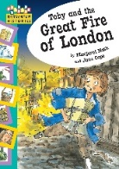  Parallel texts:  - Vlad and the Great Fire of London – Kate Cunningham  - The Baker’s Boy and the Great Fire of London - Tom & Tony Bradman | Key Drivers  Geography – Locational knowledge  Text Driver A:  Lost and Found – Oliver Jeffers  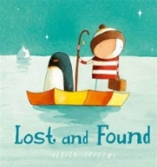  Parallel texts:  - The Elephant Detectives – Ged Adamson | Key Drivers  History – Life of a significant individual  Text Driver A:  The day the crayons quit  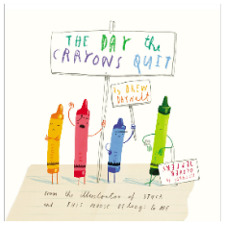  Parallel texts:  - The day the Crayons Came Home – Drew Daywalt | Key Drivers  Science – Living things and their habitats  Text Driver A:  The Night Gardener  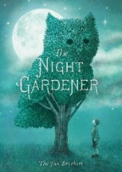  Parallel texts:  - Hedgehogs -  - The Woolly Bear Caterpillar – Julia Donaldson | Key Drivers  Geography – Place knowledge  Text Driver A:  Charlie and the chocolate factory  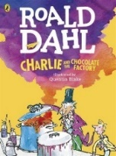  Parallel texts:  - Author study (extracts) | Key Drivers  History – historical event (local)  Text Driver A:  Samson’s Titanic Journey – Lauren Graham  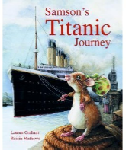  Parallel texts:  - The story of the Titanic  - Noah’s Ark
English | Text Driver B:  The Three Little Wolves and the Big Bad Pig – Helen Oxenbury & Eugene Trivias  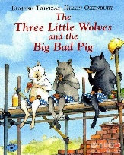  Parallel texts:  Versions of the three little pigs | Text Driver B:  Stick man – Julia Donaldson  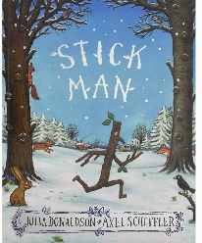  Parallel texts:  - The Santa Trap – Jonathan Emmett | Text Driver B:  Malala’s Magic Pencil  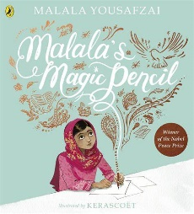  Parallel texts:  - The Global Game Changers – Jan & Rachel Helson | Text Driver B:  Tidy – Emily Gravett  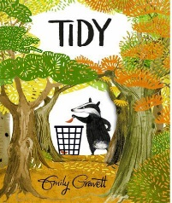  Parallel texts:  Dear Greenpeace – Simon James |  | Text Driver B:  Saving the Butterfly – Helen Cooper  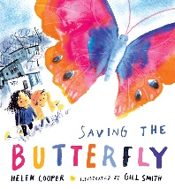  Parallel texts:  The Proudest Blue – Ibtihaj Muhammed
English | Poetry –  - The Three Little Pigs by Roald Dahl (Revolting Rhymes) | Poetry –  - Eletelephony – Laura Richards  - Talking Turkeys – Benjamin Zephania | Poetry –  - Colour by Christina Rosetti | Poetry -  - When Daddy fell into the pond – Alfred Noyes | Poetry –  - On the Ning Nang Nong – Spike Milligan  - Chocolate Cake - Michael Rosen | Poetry -  - When Daddy Fell into the Pond by Alfred Noyes
RE | Christian tradition –  Concept – Bread as a symbol  What is bread a symbol of?  Fellowship | Christian traditions-  Concept – Giving at Christmas  Why does Christmas matter to Christians?  (Golden Thread - special)  Love | Jewish traditions  Passover  Concept – Remembering  How do Jewish families celebrate Passover?  Bible story – Moses and the 10 plagues  Fellowship | Christian traditions -  Concept – Welcoming: Easter  What is the importance of Palm Sunday?  Bible story – Easter story  Love | Jewish Traditions -  Concept – Special  What is special about a synagogue?  Fellowship | Christian traditions  Concept – Creation stories  What does creation mean?  Golden thread – community  Love
SAFEGUARDING | Using Year 1/2 provision safely  Fire Safety – Fire Brigade | Green Cross Code (HCC led session) | Pants rule, internet safety | School trip safety: Chichester Harbour | Online Safety: My on-line community | School trip safety -Titanic Museum  Water safety
SCIENCE | Use of everyday materials  - Identify and compare the suitability of a variety of everyday materials, including wood, metal, plastic, glass, brick, rock, paper, and cardboard for particular uses  - Find out how the shapes of solid objects made from some materials can be changed by squashing, bending, twisting, and stretching. |  | Animals including humans  - Notice that animals, including humans, have offspring which grow into adults  - Find out about the basic needs of animals, including humans, for survival (water, food, and air)  - Describe the importance for humans of exercise, eating the right amounts of different types of food and hygiene  Spirituality: self | Living Things – Habitats  - Explore and compare the differences between things that are living, dead, and things that have never been alive  - Identify that most living things live in habitats to which they are suited and describe how different kinds of animals and plants, and how they depend on each other  - Identify and name a variety and animals in their habitats, including microhabitats  - Describe how animals obtain their food from plants and other animals, using the ideas of a simple food chain, and identify and name different sources of food  Love  Spirituality: Wonder | Plants  - Observe and describe how seeds and bulbs grow into mature plants  - Find out and describe how plants need water, light, and a suitable temperature to grow and stay healthy
SCIENCE | Year 1 ONLY: Seasonal Changes and ALL YEAR GROUPS: Working Scientifically throughout each unit
HISTORY | Great Fire of London  - Events beyond living memory that are significant nationally or globally  Courage | Gunpowder Plot  - Significant historical event. Guy Fawkes and the Gunpowder Plot  Light touch | Rosa Parks & Emily Davison  - Lives of significant individuals in the past who have contributed to national and international achievements. Compare aspects of life in different periods  Courage  Spirituality: Others | - | - | Titanic  - Significant historical events, people, and places in their own locality
GEOGRAPHY | Locational knowledge  - Name, locate and identify characteristics of the four countries and capital cities in UK and the seas. | Locational knowledge  - Name and locate the world’s seven continents and five oceans.  Human and physical geography  - Identify the location of hot and cold areas of the world in relation to the Equator and the North and South  Geographical skills and fieldwork  - Use world maps, atlases and globes to identify the United Kingdom and its countries, as well as the countries, continents and oceans. | - | Geographical skills and fieldwork  - Use simple fieldwork and observational skills to study the geography of their school and its grounds and the key human and physical features of its surrounding environment. | Place Knowledge  - Understand geographical similarities and differences through studying the human and physical geography of a small area of the United Kingdom, and of a small area in a contrasting non-European country  Human and physical geography  - Use basic geographical vocabulary to refer to:  - key physical features, including: beach, cliff, coast, forest, hill, mountain, sea, ocean, river, soil, valley, vegetation, season and weather  -key human features, including: city, town, village, factory, farm, house, office, port, harbour and shop | -
ART | - | - | Painting and printing  - Use drawing and painting to develop a range of art techniques, using colour, pattern, line, shape, form and space.  - Look at the work of a range of artists, craft makers and designers (with a focus on Kandinsky), describing the differences and similarities between different practices and disciplines, and making links to their own work | Collage  - Develop painting skills, including finding ways to create texture  - Use a range of materials creatively to design and make products  - Know about the work of a range of artists - Romare Bearden | - | Drawing/sketching  (Through the porthole)  - To use drawing, painting, and sculpture to develop and share their ideas, experiences and imagination  Spirituality: Wonder
DT | House from 1666  - Select from and use a range of materials and components to make a house from 1666 to set fire to – linked to Great Fire of London | Christmas sleigh  - Design a purposeful, functional and appealing product based on design criteria  - Select and use a range of tools and materials to create a sleigh (cutting, shaping, joining and finishing)  - Evaluate their product against design criteria | - | - | Healthy wraps  - Design an appealing product for themselves and others based on design criteria  - Select ingredients  - Evaluate their product  Spirituality: self | -
PSHE | Family and relationships  KS1 RSE PSHE Lessons on Family and Relationships - Scheme (kapowprimary.com)  Bk - The Family tree – Kate Ferdinand (stepfamilies)  - Explain how school council works (lesson 6 – citizenship  Love  Spirituality: Self and others | Health and well-being  KS1 RSE & PSHE Lesson Plan | Health and Wellbeing (kapowprimary.com)  Bk - Whirly Twirly Me – Manjeet Mann  Spirituality: self | Safety and the Changing Body (including Pants rule)  Y2 Safety and the changing body (kapowprimary.com) | Citizenship (including stewardship)  PSHE RSE Citizenship Lessons KS1 Y2 - Kapow Primary  Fellowship  Spirituality: others | Economic well-being (money)  KS1 RSE & PSHE | Economic Wellbeing Y2 (kapowprimary.com) | PSHE: Transition to KS2
MUSIC | London’s Burning  - Use voices expressively and creatively by singing songs  - Play tuned and untuned instruments musically | Christmas Nativity  - Use voices expressively by singing songs | Protest rhythm  - Use voices to speak chants and rhymes  Fellowship | British sounds and songs  - Experiment with, create and combine sounds  - Understand and use simple musical notations | West African Song  - Listen to recorded music with concentration and understanding  - Listen to music from different genres, styles and traditions | Titanic – String quartet  - Listen with concentration and understanding to music  - Evaluate music across a range of historical periods  - Use musical language, such as pitch, tempo and dynamics  Courage  Spirituality: meaning and purpose
COMPUTING | Computing Charter  Computing systems and networks 1:  IT around us | Creating Media:  Digital photography | Programming A:  Robot algorithms | Data and Information  Pictograms | Creating media:  Digital music | Programming B  Programming quizzes
E-safety |  | How do I keep my things safe online? | How do I keep my things safe online? |  | It’s my choice (permissions) | Is it true?
PE/GAMES | Dance - imoves - Great Fire of London  NC: Perform dances using simple movement patterns.  Balance, agility and co-ordination  Fundamentals – GS4PE  NC: Master basic movements including running, jumping, throwing and catching  Catching and passing a ball | Nativity  Dance – Nativity  NC: Perform dances using simple movement patterns.  Fellowship  Courage  Spirituality: Meaning and purpose  Ball skills – GS4PE  NC: Master basic movements including running, jumping, throwing and catching  Participate in team games,  Catching and passing a ball | Gymnastics - GS4PE NC: Developing balance, agility and co-ordination, and begin to apply these in a range of activities  Balance, agility and co-ordination  Sending and receiving - GS4PE  NC: Participate in team games, developing simple tactics for attacking and defending  Master basic movements including running, jumping, throwing and catching,  Catching and passing a ball | Team Building – GS4PE  NC: Participate in team games,  Teamwork  Target Games – GS4PE  NC: Master basic movements including running, jumping, throwing and catching,  Participate in team games, developing simple tactics for attacking and defending  Catching and passing a ball | imoves – dance. Countries/continent Africa  - GS4PE  NC: Perform dances using simple movement patterns.  Balance, agility and co-ordination  Net and wall games  NC: Participate in team games, developing simple tactics for attacking and defending  Catching and passing a ball | Athletics  NC: Master basic movements including running, jumping, throwing and catching, as well as developing balance, agility and co-ordination, and begin to apply these in a range of activities  Balance, agility and co-ordination  Striking and Fielding - GS4PE  NC: Participate in team games, developing simple tactics for attacking and defending  Master basic movements including running, jumping, throwing and catching  Catching and passing a ball
ST ALBAN’S PROMISES, CURRICULUM EXPERIENCES | - Setting fire to the houses they have created.  - Fire brigade visit  - Visitor - Weald and Downland Museum | Nativity |  | Trip – Chichester Harbour | Chocolate Workshop – in school | Trip –Titanic Museum

